2024 TRI-COUNTY

HEALTH DEPARTMENT

COMMUNITY HEALTH ASSESSMENT

(DEKALB AND GENTRY COUNTY)

PREPARED BY

L. COREY SLOAN, EdD, MPH, MS, MA

OCTOBER 2024

**TABLE OF CONTENTS**

**TABLE OF CONTENTS** 1-2

**NOTE FROM CONSULTANT** 3-6

**INTRODUCTION** 7

**COMMUNITY HEALTH ASSESSMENT 2024** 8-9

**FACTS AT A GLANCE** 10

**PURPOSE** 11-12

**METHODOLOGY** 13-15

**DATA ANALYSIS OVERVIEW** 16-17

**COMMUNITY OVERVIEW** 18

**DEMOGRAPHICS** 19-23

**MOPHIMS ANALYSIS** 24-29

**SOCIAL DETERMINANTS OF HEALTH** 30-36

**PUBLIC SAFETY** 36-37

**SUBSTANCE USE AND MENTAL HEALTH** 38-45

**UNINTENTIONAL INJURIES** 46-49

**MATERNAL AND CHILD HEALTH** 50-58

**EMERGING INFECTIOUS DISEASE** 59-62

**CHRONIC DISEASE** 64

**HEALTHCARE ACCESS** 65-66

**COMMUNITY HEALTH RESOURCES** 67-70

**SUMMARY OF FINDINGS** 71

**RECOMMENDATIONS/PRIORITY HEALTH ISSUES** 72

**TARGETED STRATEGIES AND INTERVENTION** 73-74

**KEY PERFORMANCE INDICATORS** 75-77

**CONSULTANT CLOSING COMMENTS** 78-79

**APPENDICES** 80

A - Community Health Assessment Survey 80-90

**NOTE FROM THE CONSULTANT**

**____________________________________________________**

Viking Emergency Preparedness Consultants, LLC is pleased to present the comprehensive Community Health Assessment (CHA) conducted across counties served by the Tri-County Health Department (TCHD). This assessment represents a collaborative effort to understand the health needs, challenges, and strengths of the communities within our jurisdiction. This CHA aims to provide a data-driven foundation that informs strategic planning, prioritization of resources, and the development of targeted interventions to improve public health outcomes. Throughout the assessment process, we employed a variety of methodologies, including quantitative data analysis, community surveys, stakeholder interviews, and focus groups. This mixed-methods approach allowed us to capture residents' statistical realities and lived experiences across the counties. We have also aligned our findings with state and national public health benchmarks to comprehensively understand the region's health landscape.

The CHA reveals vital insights into the social determinants of health, health disparities, and priority health concerns such as chronic disease prevalence, mental health challenges, and access to healthcare services. Notably, the findings highlight opportunities and existing community assets that can be leveraged to address these issues effectively. This report marks a significant step toward building a healthier, more equitable future for all residents of the Tri-County area. We hope the TCHD and its partners will use this assessment as a foundation for action, guiding evidence-based interventions and policy decisions aligning with our communities' unique needs and aspirations.

Viking Emergency Preparedness Consultants, LLC extends our deepest gratitude to the Tri-County Health Department’s administration, staff, and board for entrusting us with the opportunity to prepare this comprehensive CHA. Working alongside a team so deeply committed to improving the health and well-being of the communities served has been an honor. Your dedication, collaboration, and support throughout this process have been invaluable in ensuring the thoroughness and accuracy of our work. We appreciate the opportunity to partner with such a forward-thinking and community-focused organization, and we look forward to seeing the positive impact of this CHA as you continue to build a healthier, more resilient future for all residents. Thank you for your trust and partnership, and we look forward to our continued relationship.

**Limitations**

The 2024 TCHD CHA is comprehensive and aligns with accepted community health assessment methodologies. The report employs the Mobilizing for Action through Planning and Partnerships (MAPP) framework, incorporating quantitative data analysis, community surveys, and qualitative insights from stakeholders and residents.

However, some aspects could be enhanced so that the CHA can be considered fully comprehensive and actionable. These include:

* **Expanded Mental Health and Substance Use Analysis**: While the assessment addresses mental health and substance use issues, a more in-depth exploration of existing gaps in services and resources, particularly for marginalized groups, would strengthen the report. A detailed analysis of access barriers, such as provider shortages and the availability of telehealth options, could provide more actionable insights.
* **Health Equity and Social Determinants of Health**: The CHA identifies socioeconomic and demographic disparities impacting health outcomes but could further emphasize strategies specifically addressing these inequities. Recommendations to implement policies targeting housing, education, and income disparities would align more closely with health equity goals.
* **Actionable Health Improvement Plan**: The CHA lays a strong foundation for a Community Health Improvement Plan (CHIP) but should include more specific, measurable objectives, timelines, and designated roles for stakeholders. This would help transition the assessment from identification to actionable intervention planning.
* **Robust Public Health Funding**: To ensure the effective implementation of health initiatives, TCHD must secure and advocate for sustainable, robust public health funding. Relying primarily on grants is unsuitable for health department operations, as these funds are typically short-term, restrictive, and unpredictable. Additionally, grants demand a substantial commitment from staff to manage application processes and fulfill frequent reporting requirements, including monthly, quarterly, and annual progress reports. Reliable funding streams are critical to building and maintaining consistent public health services that adapt effectively to emerging needs and sustain long-term public health goals for the citizens served. Investing in core infrastructure and resources allows TCHD to sustain and expand its programs without the limitations imposed by temporary grants.
* **Community Engagement and Participation Rates**: The report mentions a low survey completion rate (less than 1% participation). Increasing community engagement through varied outreach methods (bilingual survey) and expanding efforts to include underrepresented areas such as King City and Fairport could provide a more accurate picture of the community's needs and priorities.

In conclusion, the 2024 TCHD Community Health Assessment (CHA) provides a comprehensive and methodologically sound evaluation of the region's health landscape, utilizing the MAPP framework to integrate diverse data sources, including community surveys and stakeholder insights. However, several enhancements are recommended to fully capitalize on this foundation and make the assessment more actionable. These include a deeper exploration of mental health and substance use issues, mainly focusing on marginalized populations and the accessibility of telehealth services. Additionally, emphasizing strategies that directly address health equity and social determinants, such as housing, education, and income, would align the CHA with broader public health goals. Furthermore, the CHA would benefit from a more detailed and measurable CHIP with specific objectives, timelines, and stakeholder responsibilities. Finally, improving community engagement, especially in underrepresented areas, through expanded outreach methods would provide a more accurate and inclusive understanding of the community’s health needs, thereby strengthening the overall impact of the CHA.

**INTRODUCTION**

**____________________________________________________**

The Tri-County Health Department completed a comprehensive CHA using the MAPP 2.0 methodology and framework. This assessment is a collaborative effort to identify the community's health needs, strengths, and priorities, guiding future public health interventions and policies based on evidence and community input.

MAPP 2.0 provides a structured approach to community health improvement, emphasizing integrating quantitative data with qualitative insights gathered from residents, community partners, and stakeholders. The CHA process included three primary assessments: the Community Context Assessment (CCA), the Community Status Assessment (CSA), and the Community Partner Assessment (CPA). These components collectively offered a detailed picture of the social determinants of health, healthcare access, quality of life, and the existing capacities within the community to support health equity.

All three assessments—Community Context Assessment (CCA), Community Status Assessment (CSA), and Community Partner Assessment (CPA)—were integrated into the comprehensive CHA. The CCA explored residents' perceptions of the health and safety of their environment, with survey findings highlighting priorities such as quality healthcare, education, and mental health resources. The CSA, grounded in quantitative data from reliable sources like the US Census and County Health Rankings, provided an overview of demographic trends, health behaviors, and community disparities. Additionally, the CPA engaged local organizations to evaluate their collective capacity and commitment to addressing health inequities, ensuring alignment with MAPP's health equity goals. The CHA offers a holistic view of the community's health status and needs by incorporating insights from all three assessments. The insights gained through this MAPP-driven assessment will form the TCHD Community Health Improvement Plan (CHIP) foundation. This ongoing effort aims to implement strategies that address the root causes of health disparities and promote equitable access to resources and services across the Tri-County area.

**Community Health Assessment 2024**

The public health community assessment for Dekalb and Gentry Counties, conducted using the MAPP 2.0 framework, highlights significant areas of need and opportunities for community health improvement. Data collection methods included surveys, community partner assessments, and quantitative data analysis to capture a comprehensive view of the health status and social determinants affecting the residents of these counties.

**Dekalb County Assessment**

Dekalb County's population faces substantial challenges related to healthcare access, socioeconomic disparities, and chronic health conditions. The county has a significant aging population, with a high percentage of residents aged 65 and older. This demographic shift increases the demand for healthcare services, particularly chronic disease management such as hypertension, diabetes, and cardiovascular conditions. Socioeconomic factors play a pivotal role in influencing health outcomes. A notable portion of the population lives below the poverty line, with limited access to affordable housing and transportation. The lack of public transportation complicates access to healthcare facilities, especially for low-income and elderly residents who often travel significant distances to receive medical care. Substance use and mental health services are also critical concerns. The county's rural setting limits access to mental health providers, and many residents travel outside the county for care. Substance use, particularly tobacco and alcohol, is prevalent, indicating a need for expanded prevention and treatment resources. Additionally, emergency response services face delays due to the geographic layout of the county, impacting outcomes for residents needing urgent medical assistance.

**Gentry County Assessment**

Gentry County mirrors many of Dekalb County's public health challenges but faces distinct issues tied to its economic structure and healthcare infrastructure. Gentry County also has an aging population, contributing to a higher prevalence of chronic illnesses. However, healthcare provider shortages and limited emergency services present significant barriers to managing these conditions effectively.

Economic instability in Gentry County is another critical issue. A considerable percentage of residents live below the poverty threshold, which directly impacts their ability to access nutritious food, secure stable housing, and receive timely healthcare services. While a strength, the county's agricultural economy contributes to higher rates of unintentional injuries related to farm work and vehicular accidents.

Similar to Dekalb County, Gentry faces challenges related to substance use and mental health services. The limited number of providers means residents often travel long distances for care, creating access barriers. Survey data reveals a need for mental health resources and substance use prevention programs tailored to the local population.

**Overall Findings**

The combined assessment of Dekalb and Gentry Counties shows that both communities face similar obstacles, including aging populations, economic hardships, and healthcare access challenges. The assessment underscores the importance of addressing social determinants of health, such as economic stability, transportation, and housing quality, to improve overall health outcomes. Public health strategies must focus on expanding local healthcare resources, improving emergency response systems, and enhancing preventive care services for chronic disease management. The results from this assessment will inform the development of a CHIP that prioritizes these areas, aligns with the identified needs, and leverages community strengths and partnerships to build a healthier future for both counties.

**Facts at a Glance**

* The CHA had 232 residents participate in the CHA survey, equating to less than a 1% completion rate based on the 2020 US census population of Dekalb and Gentry Counties (17,196). Three persons left the consent response blank on the hard copy, and two responded that they did not consent to complete the survey – these were not included in the analysis.
* A majority of the communities in the county were represented in the survey. The areas not represented include King City, Fairport, rural Pattonsburg, and Worth (Worth data was collected in a previous survey) as identified by the provided zip code, with the highest percentage of participants completing the survey residing in Stanberry (17.6%)followed by Maysville (17.2%). The highest percentage in Gentry County was Albany (16.7%) (See Figure 2.)
* Females accounted for most participants, with a 77.2% participation rate, and males 20.39%. Five persons preferred not to answer, and one person answered other.
* Persons aged 36-45 had the highest completion percentage at 22.8%.
* A holistic overview of the sample demographic indicated average health (37.9%) and somewhat good health (35.8%). Only 2.6% of the sample reported poor health, and 11.2% reported excellent health.
* 24.6% of the participants reported attending college, and 24.1% of the sample possessed bachelor's degrees. Only 3.4% reported not completing high school, 16.4% had a master's degree, and 2.6% had a doctoral degree.
* Participants 19.4% reported a household income of 60,000 to 79,999 (194%), and 17.2% reported a household income of 80,000 to 99,999 (17.2%). 6.9% of the participants reported a household income of $0 to $19,999, and 14.7% reported a household income of $120,000+.
* The participants identified the top three priority health issues in Dekalb and Gentry Counties as 1) Education 72.3% (76), 2) Safe and Healthy Homes 39.2%, and 3) Adequate Employment 24.1% (56). The last important priority for the participants was transportation at 43.5% (101).
* Of the participants who received health information from a doctor or physician, 62.1% (144) and 19.0% (44) received information from the Internet/social media. The lowest form of health information received was from newspapers at 0.4% (3). 6.9% (16) of the participants indicated they received health information from the TCHD.

PURPOSE

**____________________________________________________**

Soriano (2013) indicates that needs assessments are "*conducted by organizations to determine the nature of problems affecting them and seek ways to overcome* them. A CHA provides the foundation for improving and promoting the community's health. A community health needs assessment identifies and describes factors that affect the health of a population in correlation with available resources within the community to address health concerns and disparities.

**UNDERSTANDING RURAL VERSE URBAN AREAS**

Understanding the distinctions between rural and urban areas is crucial when conducting a CHA. However, definitions of these areas vary across local, state, and federal agencies. The consultant utilized federal guidelines to distinguish between rural and urban populations for consistency. It is important to note that federal agencies do not use a standardized definition for "rural"; instead, definitions differ based on their specific data needs. For instance, some agencies use population thresholds (fewer than 2,500, 5,000, or 10,000 people) and geographic classifications like census blocks, tracts, ZIP codes, places, or counties. The Census Bureau does not explicitly define "rural"; instead, it categorizes rural areas as all regions not classified as urban. According to data from the United States Census Bureau and the American Community Survey (ACS) in 2020, approximately 61 million people, or 19 percent of the US population, resided in rural areas as of 2016. Although these rural areas account for less than one-fifth of the population, they comprise about 97 percent of the country's total land area (United States Department of Commerce, 2020, p. 2). For the CHA conducted in Dekalb and Gentry Counties, the Office of Management and Budget (OMB) definition was applied, considering all counties outside metropolitan areas as rural (based on the 2020 census data). Under this definition, rural areas in the US encompass approximately 48.8 million people (17% of the population) and cover 75% of the nation's land area.

In Missouri, 97.4% of the land is classified as rural, housing 30.6% of the state's population. This contrasts with the fact that 70% of Missouri's population resides in only 2.6% of the land. Similarly, on a national scale, while 97.4% of the US land is rural, only 21% of the population lives in these areas. This uneven population distribution creates diverse and complex public health challenges when identifying and addressing priority health issues, considering rural populations' disparities and lifestyle differences (see Figure 1).

**Figure 1.**

*Missouri Nonmetro Population – 2020 Estimate*

METHODOLOGY

**____________________________________________________**

**SAMPLING**

The sampling approach used for the CHA was non-purposive, meaning there was no intention or assurance that the sample would accurately represent the population. The primary method employed was convenience sampling. According to Leedy and Ormrod (2019), "Convenience sampling does not identify a representative subset of the population. It takes people or other readily available units to participate" (p. 177). This method was applied by soliciting participants from Dekalb and Gentry County residents via electronic surveys, hard-copy surveys, and community outreach facilitated by the consultant and the health department without guaranteeing participation. In addition to primary data collection, secondary data was sourced for further analysis. This included information from the State of Missouri Department of Health and Senior Services (DHSS), the Missouri Public Health Information Management System (MOPHIMS), and Missouri Kids. Other secondary sources included data from Datausa.io, USA Facts, the United States Census Bureau, and the American Community Survey (ACS). Gray literature was also reviewed to supplement the CHA data.

**DATA COLLECTION**

In the fall of 2023 and summer of 2024, the TCHD, in partnership with Viking Emergency Preparedness Consultants, LLC, conducted a comprehensive electronic survey across Dekalb and Gentry Counties. The survey was disseminated via various platforms, including the Internet, social media, and hard copies (Refer to Appendix A). It was available in English, with multilingual translations accessible upon request to ensure inclusivity. The survey questions were designed and validated by the health department's internal team, which determined that pilot testing was unnecessary due to its prior successful application in the Worth County CHA. Once finalized, the survey was launched through the Qualtrics platform, allowing residents in both counties to participate in their preferred language.

To further enhance participation, the health department distributed 6,788 mailers through the United States Postal Service (USPS) to zip codes associated explicitly with residential areas in Dekalb and Gentry Counties (See Figure 3). Each mailer contained a survey link and a QR code for easy access to the online platform. Additionally, information was provided on where residents could obtain hard copies if they lacked Internet access. Zip codes predominantly associated with neighboring counties were excluded from the mailing list to maintain data accuracy and ensure the survey reached the intended population.

**Figure 2.**

*CHA Participants by Zip Code*

**Figure 3.**

*Map of Every Day Direct Mail Delivery Locations in Dekalb and Gentry County for the CHA*

Dark green areas are where the mailer was delivered. The source is Taradel, United States Postal Service Ever Day Direct Mail Provider. (2024).

**Data Analysis Overview**

**Quantitative Analysis Summary**

Quantitative data from electronic and hard copy surveys were systematically coded and entered into SPSS, a statistical analysis software, for comprehensive processing and analysis. The data entry involved importing, reviewing, cleaning, and coding each data point to ensure accuracy and consistency. To maintain the integrity and confidentiality of the data, the consultant verified all entries in SPSS before securely deleting the electronic survey files and shredding the physical copies. The primary quantitative analysis employed involved descriptive statistics, which included calculating frequencies, percentages, measures of central tendency (mean, median, and mode), and measures of variability, such as standard deviation. Each survey question was assigned a distinct variable name in SPSS, allowing for precise data tracking. For questions with multiple-choice responses, coding utilized a Likert scale to facilitate consistent and accurate quantitative analysis. Additionally, any qualitative data identified within the surveys was processed separately using established qualitative methodologies, as outlined in the study's methodological framework. This approach ensured a rigorous, structured analysis of the quantitative data, supporting the overall validity and reliability of the findings.

**Qualitative Analysis Summary**

Qualitative data analysis is a systematic process used to examine non-numerical data, such as interview transcripts, focus group discussions, open-ended survey responses, observations, or documents, to identify patterns, themes, and insights. The process typically begins with data collection, followed by transcription and familiarization, where the researcher immerses themselves in the data to gain a deep understanding of the content. Once familiar, coding is applied, labeling data segments with codes representing specific topics, concepts, or themes. These codes are then categorized into broader themes or patterns across the data set. The researcher often applied iterative methods, moving back and forth between data, codes, and themes to refine and adjust as necessary. Qualitative data analysis involved thematic and content analysis, providing a structured approach to interpreting the data. The goal was to make sense of complex, contextualized information by identifying commonalities, contrasts, or unique cases that provide a richer understanding of public health challenges in Dekalb and Gentry County. The analysis is inherently subjective, requiring the researcher to be reflexive and transparent about their interpretation process, ensuring the findings are trustworthy and credible. The final step involved synthesizing the findings into a coherent narrative that communicates the key themes and insights drawn from the data.

COMMUNITY OVERVIEW

**____________________________________________________**

**Demographics Overview of Dekalb and Gentry Counties**

Dekalb County is in the northwest region of Missouri, with the county seat in Maysville. Established on February 25, 1845, Dekalb County was named after Johann de Kalb, a German-French military officer who served in the American Revolutionary War. As of the 2020 US Census, Dekalb County has a population of 11,029 and covers approximately 421.36 square miles. Neighboring counties include Gentry to the north, Clinton and Caldwell to the south, Daviess to the east, and Buchanan and Andrew to the west. The county ranks among Missouri's less densely populated areas, with a population density of 26.2 persons per square mile, a decrease from 30.6 persons per square mile in 2010.

In northwest Missouri, Gentry County has Albany as its county seat. Gentry County was established on February 12, 1841, and named after Colonel Richard Gentry, a hero of the Seminole War. According to the 2020 US Census, the population of Gentry County is 6,162, covering approximately 491.42 square miles. Worth County borders it to the north, Harrison and Daviess Counties to the east, and Dekalb County to the south. Gentry County's population density is 12.5 persons per square mile, reflecting a decline from 13.7 persons per square mile in 2010. Both counties have diverse economic foundations, including agriculture, light manufacturing, healthcare, and retail. However, they have experienced population declines over the past decade, mirroring broader demographic trends in rural Missouri.

**Dekalb County Demographics Analysis**

Dekalb County, located in northwest Missouri, experienced a population decline from 12,892 in the 2010 Census to 11,029 in the 2020 Census, reflecting a decrease of 14.5%. As of July 2023, the population estimate was 9,899, indicating a further decline of 10.3% since 2020. The population density is 26.2 persons per square mile, down from 30.6 in 2010. The racial composition of Dekalb County is predominantly White (93.2%), with African Americans making up 3.7% and Hispanic or Latino individuals representing 2.5%. Other racial groups, including American Indian, Asian, and Pacific Islander populations, constitute less than 1% (See Figure 4). The county has a higher proportion of individuals aged 65 and older (21.3%), indicating an aging population, while 21.8% of residents are under 18. Socioeconomically, the median household income in Dekalb County is $67,910, with a per capita income of $25,591. The poverty rate stands at 12.7%, reflecting the socioeconomic challenges in the area. Additionally, 10.3% of residents under age 65 are uninsured, and 9.1% report a disability, highlighting health-related disparities (See Figure 4).

**Gentry County Demographics Analysis**

Gentry County's population declined from 6,738 in 2010 to 6,162 in 2020. Recent estimates as of July 2023 show a slight increase to 6,287, representing a modest 2% growth since 2020. The current population density is 12.5 persons per square mile, down from 13.7 in 2010. The racial demographics of Gentry County are predominantly White (96.3%), with small representations of African American (1.0%), Asian (0.7%), and Hispanic or Latino populations (2.0%) (See Figure 5). The county also has a significant elderly population, with 18.7% of residents aged 65 and older, while 26.3% are under 18. Socioeconomically, Gentry County reports a median household income of $53,799 and a per capita income of $28,968. The poverty rate is higher than in Dekalb County, at 14.8%. The uninsured rate for residents under age 65 is 15%, and 11.2% of the population under 65 reports having a disability.

**Summary**

Both counties show significant demographic and socioeconomic challenges, including population declines, aging, and relatively high poverty rates. Dekalb County has seen a more pronounced population decrease, while Gentry County shows slight growth in recent estimates. These dynamics highlight the importance of targeted interventions addressing healthcare access, economic development, and social support systems to improve the well-being of these communities.

**Figure 4.**

*The Racial Makeup of Dekalb County – 2012 to 2022*

Source USAFacts.org. (2024)

**Figure 5.**

*The Racial Makeup of Gentry County – 2012 to 2022*

Source USAFacts.org. (2022)

**Figure 6.**

*Racial Makeup of Dekalb and Gentry County Survey Participants – 2024*

**Table 1.**

*Dekalb County Age Distribution – 2022*



Source: US Census Bureau. (2022)

**Table 2.**

*Gentry County Age Distribution – 2022*



Source: US Census Bureau. (2022)

Tables 1 and 2 provide the age distribution in Dekalb County and Gentry County. They are developed and displayed, providing a breakdown of population percentages by age group over the past five years (2016-2020). These tables highlight demographic trends within each county, demonstrating shifts in age group proportions. They also highlight an analysis of population changes, socioeconomic status, and other social determinants of health, utilizing the latest data from the US Census Bureau and other sources. Over the past five years, the population distribution in Dekalb and Gentry Counties shows a gradual decline in the younger age groups (Under 15 and 25 to 44) and a slight increase in the older demographics (65+). Notably, the 15 to 24 age group saw an increase from 19.77% in 2019 to 20.25% in 2020, while the 65+ age group remained relatively stable, showing only a minor decrease from 20.23% in 2019 to 20.19% in 2020. The aging population continues to be a public health concern, emphasizing the need for enhanced access to healthcare and transportation services, especially given the declining population density. The impact of the COVID-19 pandemic is starting to appear in the 2020 data, but further analysis is required to understand its effects on the counties fully.

**Dekalb County Analysis—2016 MOPHIMS County Level Study**

The public health assessment for Dekalb County, Missouri, provides an in-depth overview of key health indicators and outcomes based on data from the Missouri Public Health Information Management System (MOPHIMS). The findings are summarized across various domains, including general health, healthcare access, behavioral health patterns, chronic diseases, preventive practices, and environmental health considerations.

**General Health and Access to Care**

Survey data indicated that 17.65% of respondents in Dekalb County rated their general health as fair or poor, with a 95% confidence interval (CI) ranging from 12.27% to 23.03%. Additionally, 23.26% reported activity limitations, highlighting functional challenges within the population. Healthcare access is a notable concern, as 13.55% of adults aged 18-64 reported having no health insurance coverage. Among those who delayed or did not seek medical care in the past 12 months due to cost, 38.71% cited affordability as the primary barrier. Furthermore, 17.6% had not had a routine physical check-up in over two years, indicating gaps in preventive healthcare engagement.

**Oral Health and Preventive Services**

The data shows that 17.52% of individuals needed dental care within the past year but could not obtain it due to cost constraints. Additionally, 27.29% reported not visiting a dentist in over two years, possibly contributing to long-term oral health issues.

**Health Behaviors**

Risky health behaviors are prevalent in the county, with 15.99% of adults reporting binge drinking and 26.17% currently smoking cigarettes. Of those who smoke, approximately 49.74% made a quit attempt in the past year. Other forms of tobacco use, such as smokeless tobacco, were reported by 14.75% of respondents. Physical inactivity is also a concern, as 31.33% of respondents indicated no leisure-time physical activity, and 86.82% reported consuming less than the recommended five servings of fruits and vegetables daily.

**Chronic Diseases and Conditions**

Chronic disease prevalence in Dekalb County includes significant rates of arthritis (28.08%), asthma (9.35%), and chronic obstructive pulmonary disease (COPD) at 11.30%. Furthermore, 38.31% of adults reported having high blood pressure, and 14.04% have been diagnosed with diabetes. Mental health is also highlighted, with 18.81% reporting a depressive disorder diagnosis.

**Morbidity and Mortality**

The leading causes of death in Dekalb County, as reported by the MOPHIMS, were:

* **Heart Disease**: This is the most significant cause of mortality in Dekalb County, consistent with state and national trends. The prevalence of cardiovascular conditions like hypertension and coronary artery disease contributes to the high mortality rates associated with heart disease.
* **Cancer**: Various types of cancers, including lung, colorectal, and breast cancer, are prominent causes of death. Cancer screening rates show gaps, particularly in colorectal and mammogram screenings, which might contribute to late diagnoses and higher mortality rates.
* **Chronic Lower Respiratory Diseases**: Chronic obstructive pulmonary disease (COPD) and related respiratory conditions rank high among causes of death. The high smoking rates in the county are likely contributors to this statistic.
* **Stroke**: Stroke-related mortality also features prominently, linked to risk factors like hypertension, diabetes, and obesity, which are prevalent within the county's population.
* **Diabetes**: Diabetes-related complications are another leading cause of death. The high prevalence of diabetes in Dekalb County, coupled with limited access to diabetes management resources, exacerbates this trend.

Efforts to address these leading causes of death in Dekalb County should focus on enhancing preventive care services, increasing access to screenings, and promoting healthier lifestyles to reduce the burden of chronic diseases.

**Preventive Screenings**

Preventive health screenings reveal gaps in service utilization. Among adults aged 50 and older, 39.76% had never undergone a sigmoidoscopy or colonoscopy, and 45.58% had not had such screenings within the recommended time frame (10 years for colonoscopy and five years for sigmoidoscopy). Additionally, mammogram screening rates show that 43.19% of women aged 40 and older had not had a mammogram in the past two years.

**Immunization Rates**

Immunization coverage is another concern; 64.73% of adults aged 18 and older had not received a flu vaccine in the past year. For pneumonia vaccinations, 43.14% of adults aged 65 and older had never received one.

**Environmental and Neighborhood Safety**

Regarding environmental health and safety, 23.44% of indoor workers reported exposure to secondhand smoke at work, highlighting workplace health risks. While 66.10% of respondents support local laws to make indoor workplaces smoke-free, only 9.64% reported having community infrastructure, such as bike lanes, to support physical activity. Despite these limitations, 91.78% of respondents considered their neighborhoods safe, and 72.50% indicated that accessing healthy food in their community was easy.

**Health Literacy**

Health literacy indicators are relatively positive; 96.07% of respondents found it easy to access health information, and 92.89% reported that they could easily understand information provided by health professionals. However, ensuring ongoing education and support is crucial, given the high prevalence of chronic conditions and risk behaviors. This comprehensive analysis highlights the need for targeted interventions in Dekalb County, focusing on enhancing healthcare access, promoting preventive care, addressing risky health behaviors, and improving health literacy. These efforts are essential to improving overall health outcomes and quality of life for the county's residents.

**Gentry County Analysis—2016 MOPHIMS County Level Study**

The public health profile for Gentry County, Missouri, provides a comprehensive analysis of health indicators, behaviors, and access to healthcare services, highlighting critical areas of concern and opportunities for intervention based on MOPHIMS data.

**General Health and Access to Care**

In Gentry County, 20.29% of respondents reported their general health as fair or poor, and 23.05% indicated activity limitations, reflecting physical health and functional capacity challenges. Notably, 15.32% of adults aged 18-64 reported having no health insurance coverage, underscoring a gap in access to medical care. Additionally, 15.73% had not had a routine physical check-up in over two years, suggesting barriers to preventive healthcare services.

**Oral Health**

Oral health is another critical concern in Gentry County, with 15.70% of respondents indicating they needed dental care in the past year but could not afford it. Furthermore, 27.48% had not visited a dentist in over two years, potentially leading to long-term oral health issues.

**Health Behaviors**

Risky health behaviors are prevalent in Gentry County, with 12.26% of adults reporting binge drinking and 19.17% currently smoking cigarettes. Among smokers, 42.72% attempted to quit within the past year, highlighting the need for more effective smoking cessation support. The county also reports that 7.12% of respondents engage in heavy alcohol drinking, and 11.31% use smokeless tobacco. Physical inactivity is significant, with 26.06% of respondents indicating no leisure-time physical activity, while 91.88% reported consuming fewer than the recommended five servings of fruits and vegetables daily.

**Chronic Diseases and Conditions**

Chronic disease prevalence is notable, with 28.17% of adults reporting arthritis and 11.13% having asthma. Additionally, 10.88% of respondents had a history of cancer, and 8.08% reported being diagnosed with COPD. High blood pressure affects 32.59% of respondents, and 17.08% have been diagnosed with a depressive disorder, indicating significant mental health needs.

**Morbidity and Mortality**

* **Heart Disease**: The leading cause of death in Gentry County, aligning with state and national trends.
* **Cancer**: The second leading cause, including various types such as lung, colorectal, and breast cancers.
* **Chronic Lower Respiratory Diseases (COPD)**: Significant contributor to mortality, linked to smoking and other respiratory risk factors.
* **Cerebrovascular Diseases (Stroke)**: Another major cause of death, influenced by high rates of hypertension and diabetes.

These causes indicate a need for targeted preventive measures and enhanced healthcare access focusing on cardiovascular and respiratory health.

**Preventive Screenings**

Preventive health screenings in Gentry County show substantial gaps. Among adults aged 50 and older, 35.58% have never undergone a sigmoidoscopy or colonoscopy, and 43.57% have not had such screenings within the recommended time frame. For women aged 40 and older, 34.42% had not received a mammogram in the past two years, and 40.74% of women aged 18 and older had not had a Pap test in the past three years.

**Immunization Rates**

Immunization coverage in Gentry County is low, with 55.93% of adults aged 18 and older not receiving a flu vaccine in the past year. Additionally, 25.52% of adults 65 and older have never received a pneumonia vaccination.

**Environmental Health and Safety**

Exposure to secondhand smoke at work is reported by 18.63% of indoor workers, indicating a need for better smoking policies and workplace protections. However, 78.02% of respondents support local laws to make indoor workplaces smoke-free. Community infrastructure for physical activity, such as sidewalks and bike lanes, is limited, with only 10.26% of respondents noting the presence of bike lanes and 45.65% indicating their neighborhoods have sidewalks.

**Health Literacy**

Health literacy indicators are generally positive; 95.43% of respondents found it easy to access health information, and 94.47% reported that they could easily understand information from healthcare professionals. This high level of health literacy could serve as a foundation for improving health outcomes through educational initiatives and community health programs.

**Summary**

Overall, Gentry County's public health profile reveals significant challenges in healthcare access, chronic disease management, and health behavior modification. Addressing these issues requires a targeted approach focusing on preventive care, improving access to screenings, and enhancing local healthcare infrastructure to support the population's needs.

**Social Determinants of Health**

Poverty levels and economic indicators show distinct differences in Dekalb and Gentry Counties, Missouri. In Dekalb County, approximately 12.7% of the population lives below the poverty line, with a median household income of $67,910 and a per capita income of $25,591 in 2022. The county has about 44.1% of its population aged 16 and above participating in the civilian labor force. Employment has slightly declined, with a 2.3% reduction between 2021 and 2022.

On the other hand, Gentry County exhibits a higher poverty rate of 14.8%, coupled with a lower median household income of $53,799. However, its per capita income is $28,968, higher than Dekalb County's. Gentry County has a higher labor force participation rate, with 59.7% of its population aged 16 and above engaged in the civilian labor force. Despite this, the county experienced a significant 6.9% decline in employment from 2021 to 2022. These statistics indicate that while Gentry County has a higher per capita income, it faces more significant economic challenges than Dekalb County, reflected in its higher poverty rate and employment decline.

**Poverty in Dekalb and Gentry County**

Poverty levels in Dekalb and Gentry Counties, Missouri, illustrate the economic challenges faced by these communities. In Dekalb County, 12.7% of the population lives below the poverty line, indicating a significant portion of residents experiencing financial hardship. In comparison, Gentry County has a higher poverty rate, with 14.8% of its population living in poverty. These statistics, sourced from the United States Census Bureau (2024), highlight the disparities in economic conditions within these rural counties and emphasize the need for targeted interventions to support the affected populations.

**Figure 6.**

*Poverty Rate in Dekalb County*

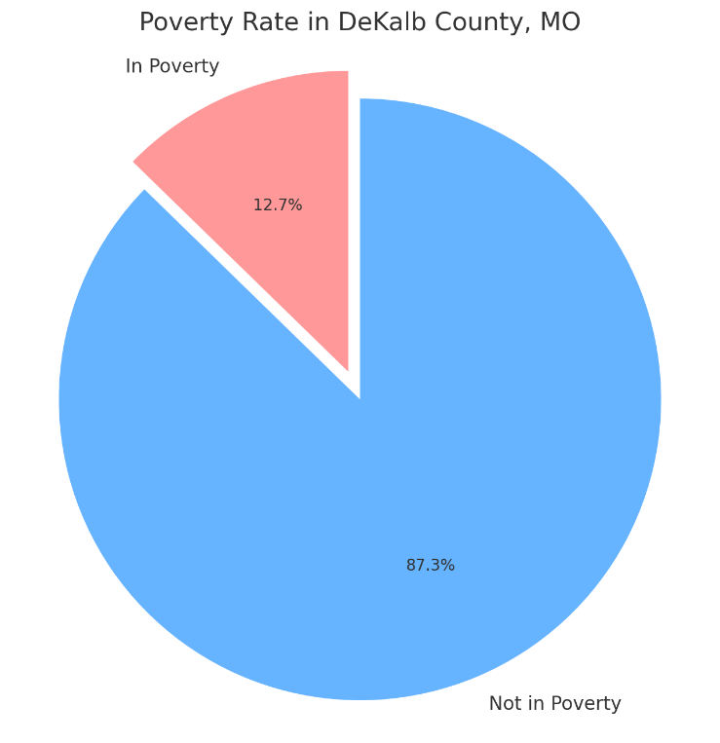

Figure 6 visualizes the poverty rate in Dekalb County. It shows that 12.7% of the population lives in poverty, while the remaining 87.3% are not considered in poverty (United States Census Bureau, 2024).

**Figure 7.**

*Poverty Rate in Gentry County*

​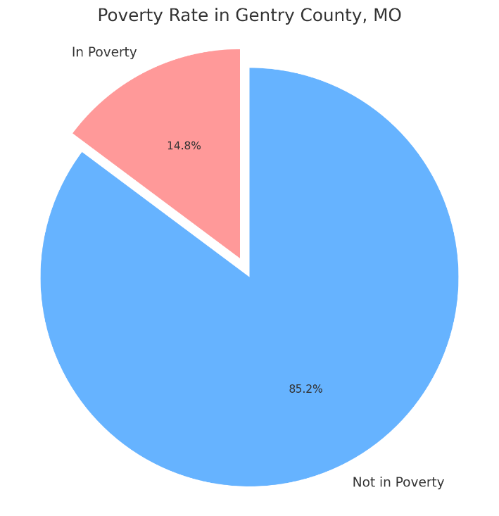

Figure 7 illustrates the poverty rate in Gentry County, Missouri. It shows that 14.8% of the population lives in poverty, while 85.2% are not (United States Census Bureau, 2024).

**Education**

In Dekalb County, the high school graduation rate is approximately 89.2%. Individuals aged 25 and older have completed high school or attained a higher level of education. ​(United States Census Bureau, 2024).

Around 14.6% of people aged 25 and above hold a bachelor's degree or higher ​(United States Census Bureau, 2024) (See Figure 8). This indicates that while most residents have achieved at least a high school diploma, a relatively small proportion has pursued higher education beyond that level.

In Gentry County, the high school graduation rate is approximately 87.6%. Individuals aged 25 and older have completed high school or a higher level of education (United States Census Bureau, 2024). Around 21.1% of the population aged 25 and above have attained a bachelor's degree or higher (United States Census Bureau, 2024) (See Figure 9). This indicates that while most of the population has completed high school, a notable proportion has also pursued higher education, with a higher percentage achieving a bachelor's degree or above than Dekalb County. Figure 10 represents the education level of the participants in the TCHD CHA.

**Figure 8.**

*Dekalb County Education Levels*

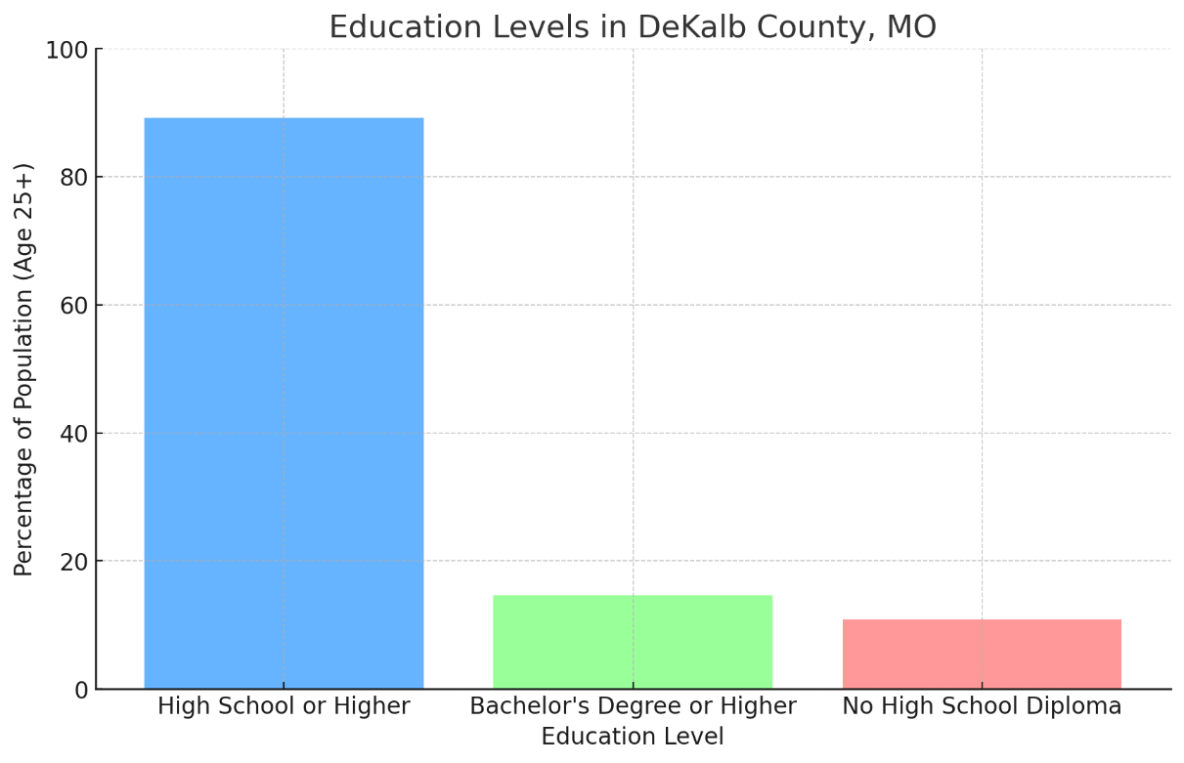

Figure 8 displays the educational attainment levels in Dekalb County, Missouri. It shows that 89.2% of the population aged 25 and older have completed high school or higher, while only 14.6% have achieved a bachelor's degree or higher. The chart also highlights that approximately 10.8% of the population has not completed high school (United States Census Bureau, 2024).

**Figure 9**.

*Gentry County Education Levels*

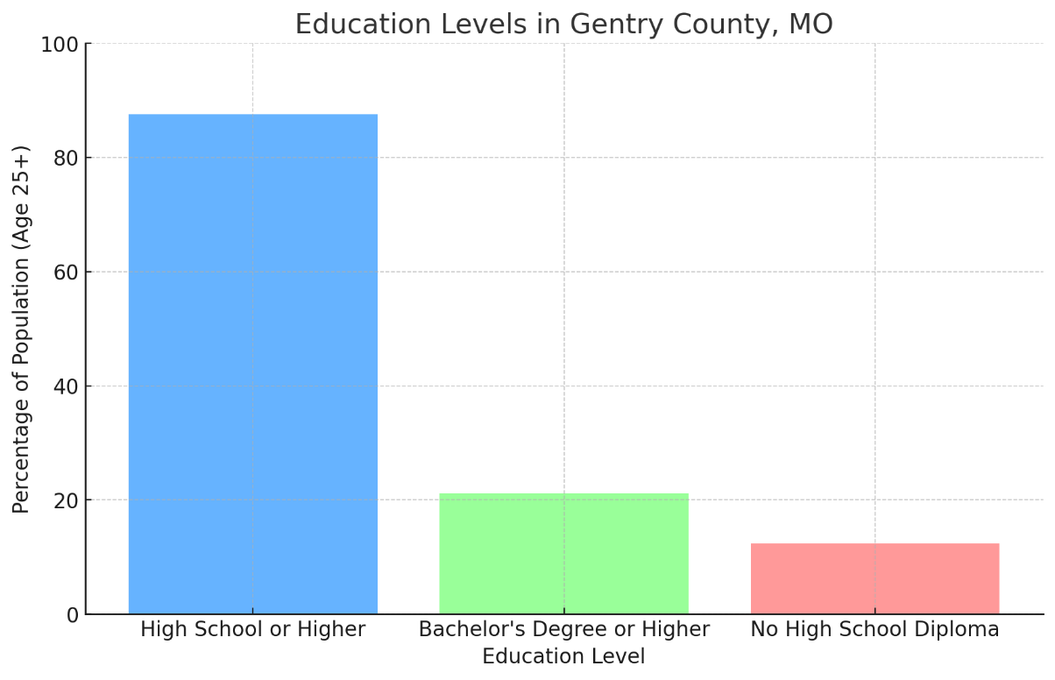

**Figure 10.**

*Survey Participant's Education Levels*

**Health Behaviors**

*Dekalb County*

In 2024, Dekalb County's health behaviors show notable concerns. Around 21% of adults are smokers, and 34% are obese, matching state trends. Physical inactivity is also high, with 29% of adults not engaging in leisure-time physical activities. Additionally, 17% of the population reports excessive drinking. These behaviors contribute to Gentry County's lower health rankings than other Missouri counties, indicating significant areas for health improvement.

**Figure 11.**

*Dekalb County Health Behaviors*

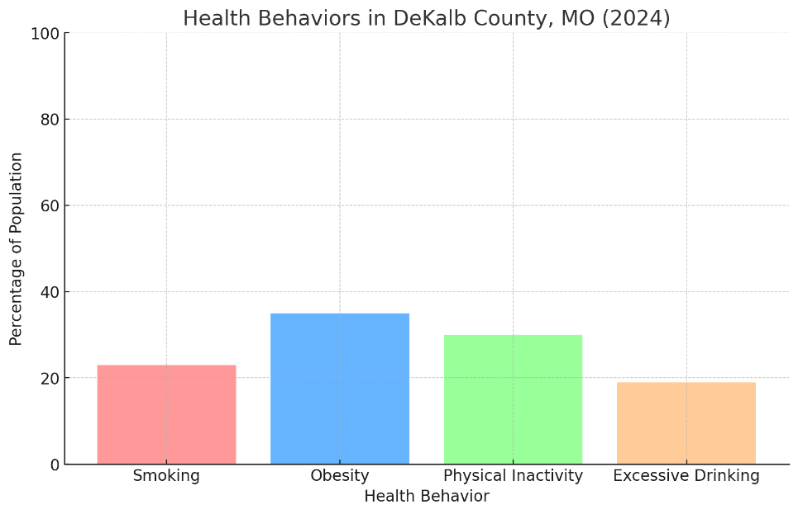

Figure 11 illustrates the health behaviors in Dekalb County for 2024. It shows that 23% of adults are smokers, 35% are obese, 30% report physical inactivity, and 19% engage in excessive drinking. This visual representation highlights critical areas where health interventions may be needed to improve overall health outcomes in the county.

*Gentry County*

In 2024, Gentry County's health behaviors show notable concerns. Around 21% of adults are smokers, and 34% are obese, matching state trends. Physical inactivity is also high, with 29% of adults not engaging in leisure-time physical activities. Additionally, 17% of the population reports excessive drinking. These behaviors contribute to Gentry County's lower health rankings than other Missouri counties, indicating significant areas for health improvement.

**Figure 12.**

*Gentry County Health Behaviors*

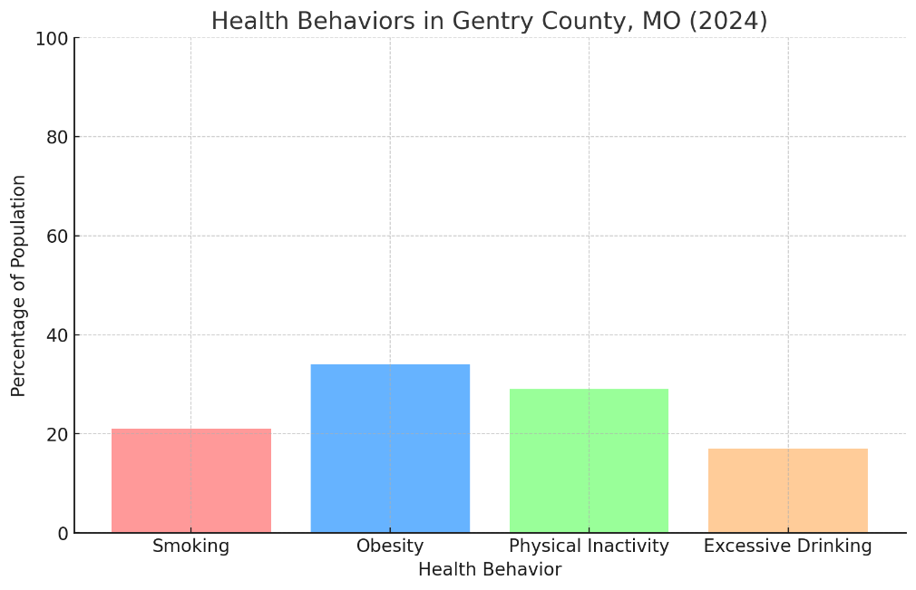

Figure 12 illustrates the health behaviors in Gentry County, Missouri, for 2024. It highlights the prevalence of smoking (21%), obesity (34%), physical inactivity (29%), and excessive drinking (17%) among adults in the county. The visual provides a clear representation of the health challenges faced by the population, emphasizing areas that may require attention for improvement.

**Crime and Public Safety**

In Dekalb County, the crime rate is moderate compared to other areas. The violent crime rate stands at about 5.05 incidents per 1,000 residents per year, which places it in the 45th percentile nationwide, meaning that it is safer than 55% of US counties. Assaults are the most common form of violent crime, while murder rates remain very low. Property crime in Dekalb County occurs at approximately 25.29 incidents per 1,000 residents annually. This includes theft, burglary, and vehicle theft. While the overall crime grade for both violent and property crime is rated as "C," the southeastern part of the county sees a higher concentration of incidents than other areas, such as the north.

**Table 3.**

*NIBRS Crimes and Rates by County per 100,000 Persons - Last 3 Years for Dekalb County*

Source: Missouri State Highway Patrol. (2022).

Gentry County's crime data is less comprehensive, but available information suggests a generally low crime rate similar to Dekalb's. Given the demographic and economic similarities between these neighboring counties, Gentry likely experiences similar trends in terms of crime distribution, focusing on less densely populated rural environments. Both counties maintain crime rates below the national average for violent and property crimes, indicating a relatively safe environment for residents.

Public safety concerns extend to emergency response times, which are prolonged due to the county's rural nature. These further impacts health outcomes during critical situations. Gentry County does not provide NIBRS crime data, which means specific crime statistics categorized under person, property, and society crimes are unavailable for this jurisdiction. This could be due to various factors, such as data reporting practices or limitations in data collection within the county. Alternative data sources were analyzed to determine crime rates for Gentry County.

**Substance Use/Mental Health**

In Dekalb County, the trends and resources related to mental health and substance abuse have shown significant changes over the past five years. According to the 2023 Missouri Substance Use and Mental Health report, there has been a steady increase in cases related to both mental health disorders and substance use treatment needs. The primary conditions affecting residents include anxiety, depressive mood disorders, and bipolar conditions. Additionally, substance use, particularly involving alcohol and methamphetamines, has become increasingly prevalent.

**Mental Health Trends**

The number of individuals receiving mental health services in Dekalb County has risen consistently. In 2020, around 150 individuals received services for disorders such as anxiety, trauma-related stress, and depressive moods. By 2022, this figure had increased to approximately 200 cases. A notable rise was observed in emergency room admissions for mental health crises, indicating a growing need for acute mental health support. This rise aligns with the increased reports of anxiety and stress-related disorders, which are becoming more common in the region.

**Figure 13.**

*Dekalb County Mental Health Disorder Case Distribution – 2022*

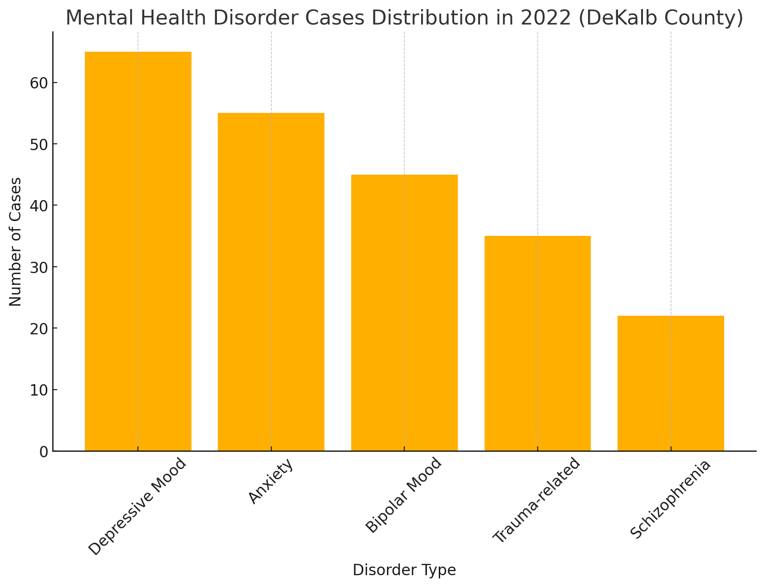

Source: 2023 Missouri Substance Use and Mental Health Report

Figure 13 presents the distribution of treated mental health disorders, with depressive mood disorders and anxiety being the most prevalent, followed by bipolar mood and trauma-related issues.

**Figure 14.**

*Dekalb County Emergency Room and Hospital Visit Trends – 2019-2022*

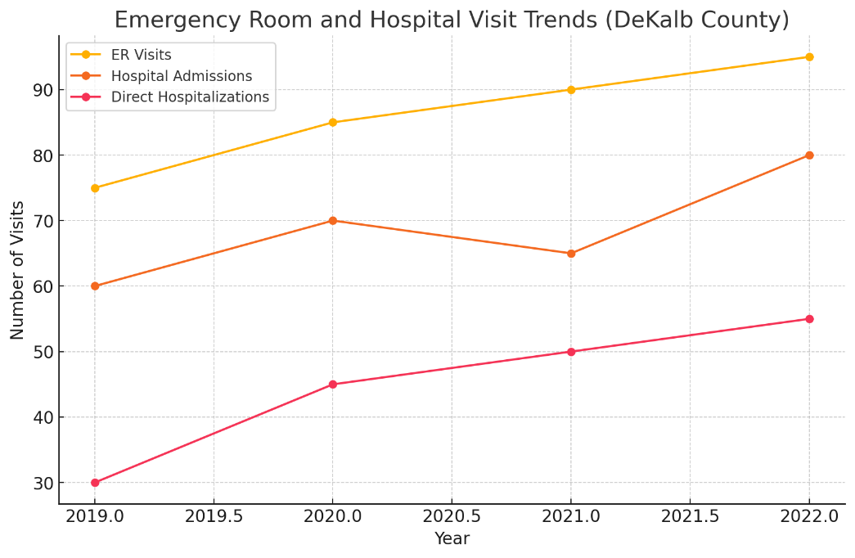

Source: 2023 Missouri Substance Use and Mental Health Report

Figure 14 shows the number of ER visits, hospital admissions, and direct hospitalizations from 2019 to 2022. The trend indicates an increase in visits and hospitalizations, reflecting a growing demand for mental health services.

**Substance Abuse and Treatment**

Substance abuse, particularly related to alcohol and methamphetamines, is a pressing issue in Dekalb County. Reports show a rise in emergency room visits and hospitalizations linked to these substances over the last five years. In 2019, there were around 60 cases of alcohol-related admissions, which grew to over 90 by 2023. Methamphetamine use has similarly seen growth, with treatment cases increasing from approximately 50 in 2020 to 75 in 2022. This trend highlights the need for expanded treatment facilities and support services.

**Figure 15.**

*Dekalb County Substance Use Disorder Cases by Substance – 2022*

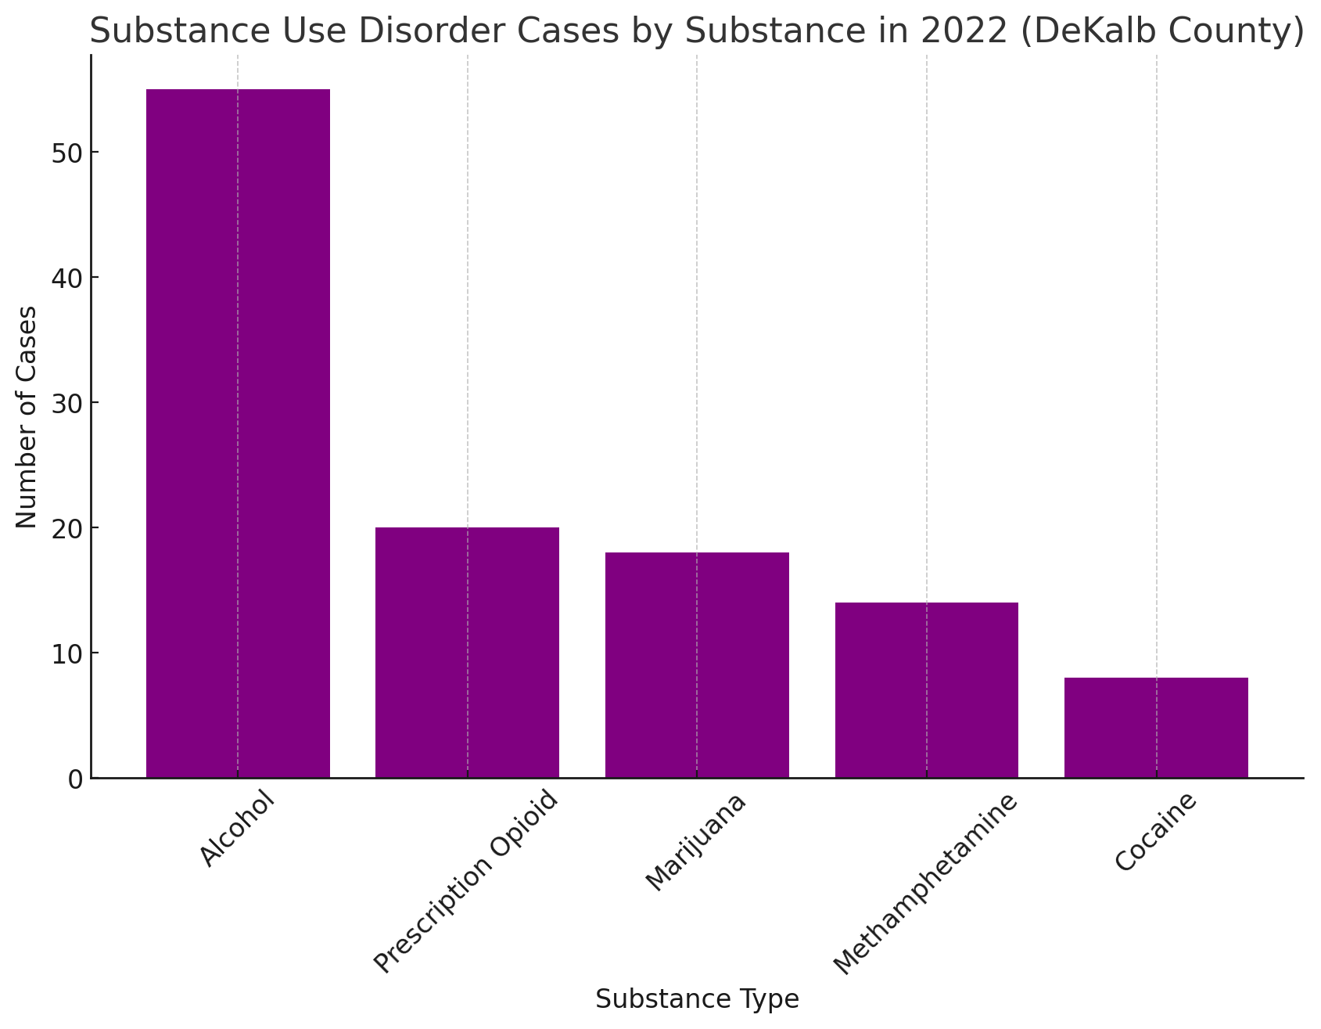

Figure 15 displays Substance Use Disorder (SUD) cases by substance type in Dekalb County for 2022. The chart indicates that alcohol is the most frequently reported substance, followed by prescription opioids, marijuana, methamphetamine, and cocaine. This visualization helps illustrate the distribution of substance-related cases, highlighting critical areas for intervention and support efforts.

**Opioid Usage**

Opioid use has shown a concerning upward trend over the past five years. Reports indicate increasing emergency room visits and hospital admissions directly associated with opioid use disorders. In 2020, the county recorded a significant number of ER discharges and hospitalizations for opioid-related incidents, which has continued to rise steadily through 2023. The introduction of programs such as the Comprehensive Substance Treatment and Rehabilitation (CSTAR) Opioid initiative has aimed to provide support and recovery options. Still, the demand for such services continues to grow.

**Figure 16.**

*Dekalb County Opioid Fatalities – 2019-2022*

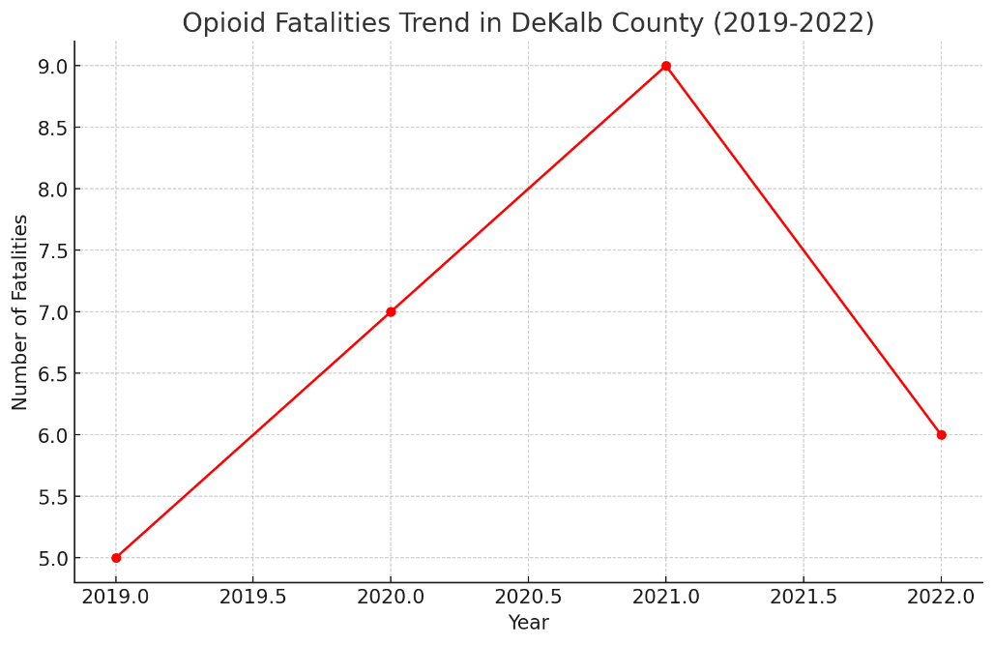

Figure 16 shows the trend of opioid fatalities in Dekalb County, Missouri, from 2019 to 2022. The chart indicates fluctuations in deaths, with a peak in 2021 followed by a slight decline in 2022. This trend highlights the ongoing impact of opioid-related issues in the county, emphasizing the need for continued monitoring and intervention efforts.

**Treatment and Support Services**

Dekalb County has expanded its support services to address these rising numbers. The Division of Behavioral Health offers both voluntary and involuntary treatment programs for individuals facing severe mental health and substance use issues. There are specialized services available for co-occurring disorders, allowing integrated treatment for individuals experiencing both mental health and substance use challenges. Crisis intervention programs have also been established to support individuals in acute distress, providing immediate assistance through hospital and emergency room admissions.

**Gentry County**

The 2023 Status Report on Missouri's Substance Use and Mental Health provides a detailed overview of mental health, substance abuse, opioid usage, and the available treatment and support services in Gentry County.

**Mental Health**

Gentry County experiences various mental health challenges, with joint disorders such as depressive mood disorders, anxiety, bipolar mood disorders, and trauma-related issues being prevalent. The county's mental health services cater to voluntary and involuntary commitments, including juvenile and civil cases. The primary referral sources for treatment often come from healthcare providers, family or friends, and the criminal justice system. The data suggests that the county has consistent utilization of psychiatric programs across these categories, with depressive and anxiety disorders among the most frequently treated.

**Figure 17.**

*Gentry County Mental Health Disorder Case Distribution – 2022*

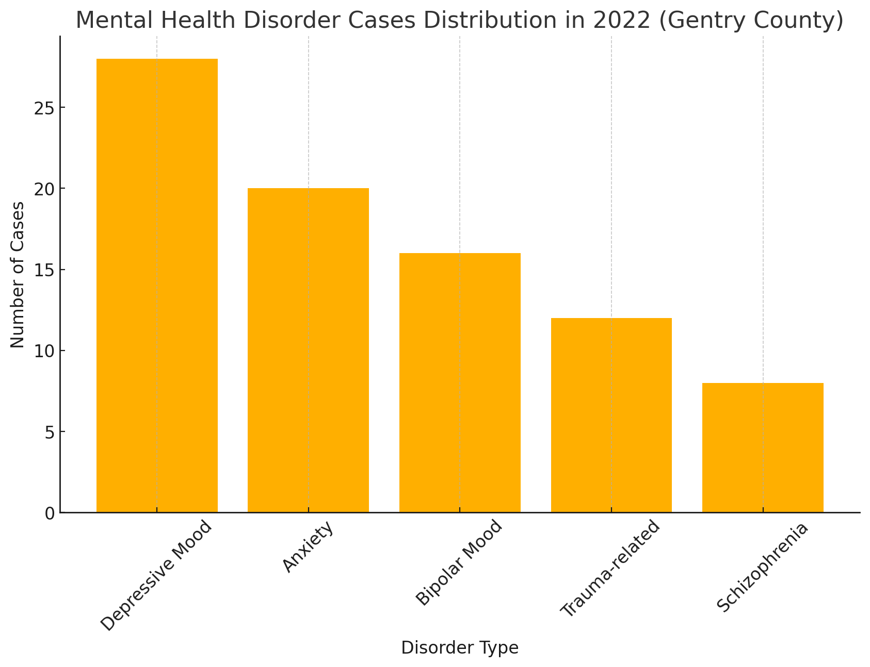

Source: 2023 Missouri Substance Use and Mental Health Report

Figure 17 presents the distribution of treated mental health disorders, with depressive mood disorders and anxiety being the most prevalent, followed by bipolar mood and trauma-related issues.

**Figure 18.**

*Gentry County Emergency Room and Hospital Visit Trends – 2019-2022*

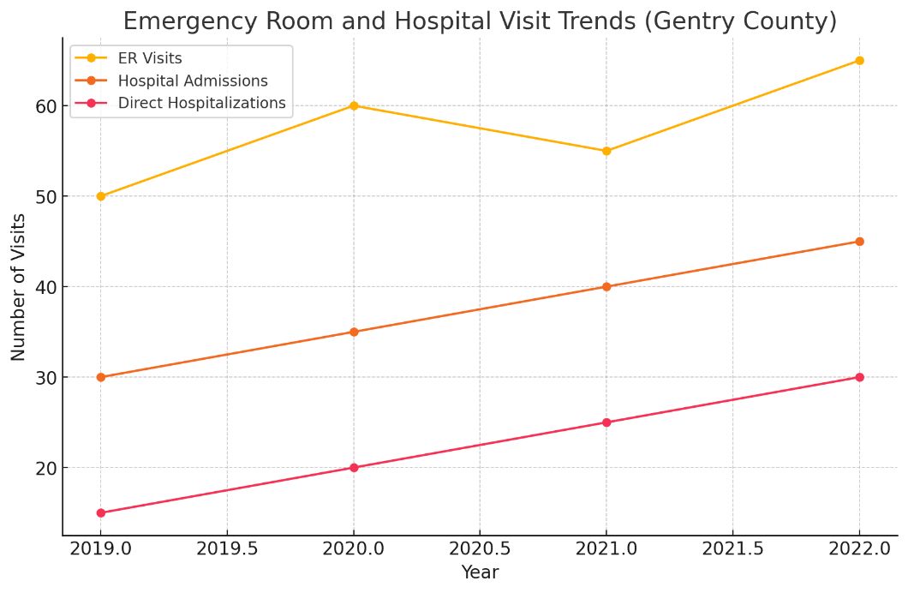

Source: 2023 Missouri Substance Use and Mental Health Report

Figure 18 shows the number of ER visits, hospital admissions, and direct hospitalizations from 2019 to 2022. The trend indicates an increase in visits and hospitalizations, reflecting a growing demand for mental health services.

**Substance Abuse**

Substance abuse treatment in Gentry County covers a range of substances, including alcohol, prescription opioids, and marijuana. Alcohol remains the most commonly treated substance, indicating that a significant portion of the population seeks help for alcohol use disorder. Other substances like prescription opioids are less frequently treated but still present a concern. The county's substance uses programs include detoxification services and opioid-specific recovery efforts, reflecting the need for targeted intervention, especially concerning opioid use.

**Figure 19.**

*Gentry County Substance Use Disorder Cases by Substance – 2022*

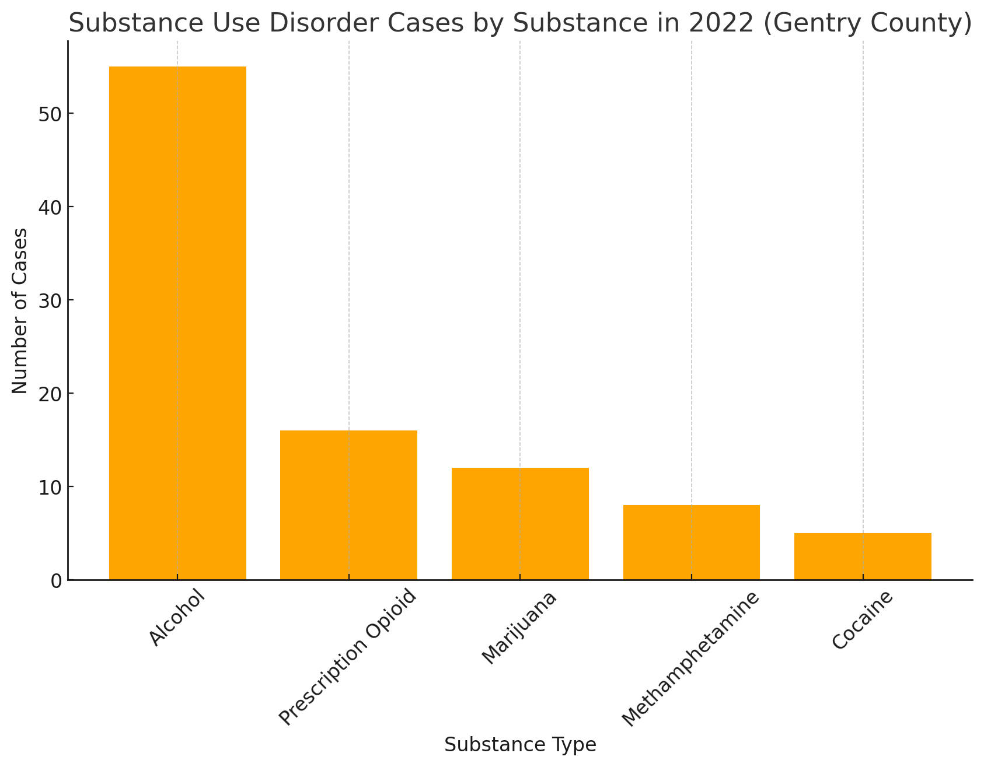

Source: 2023 Missouri Substance Use and Mental Health Report

Figure 19 displays the primary substances treated in Gentry County, with alcohol being the most common, followed by prescription opioids and marijuana.

**Opioid Usage**

The opioid crisis impacts Gentry County, though the numbers remain moderate compared to larger urban areas. Programs such as the State Opioid Response (SOR) Recovery are in place to manage cases related to prescription opioid use. The report notes that there is an emphasis on early intervention and support services to curb opioid misuse. Treatment for opioid use disorder includes various pathways, such as community-based rehabilitation and opioid-specific programs.

**Figure 20.**

*Gentry County Opioid Fatalities – 2019-2022*

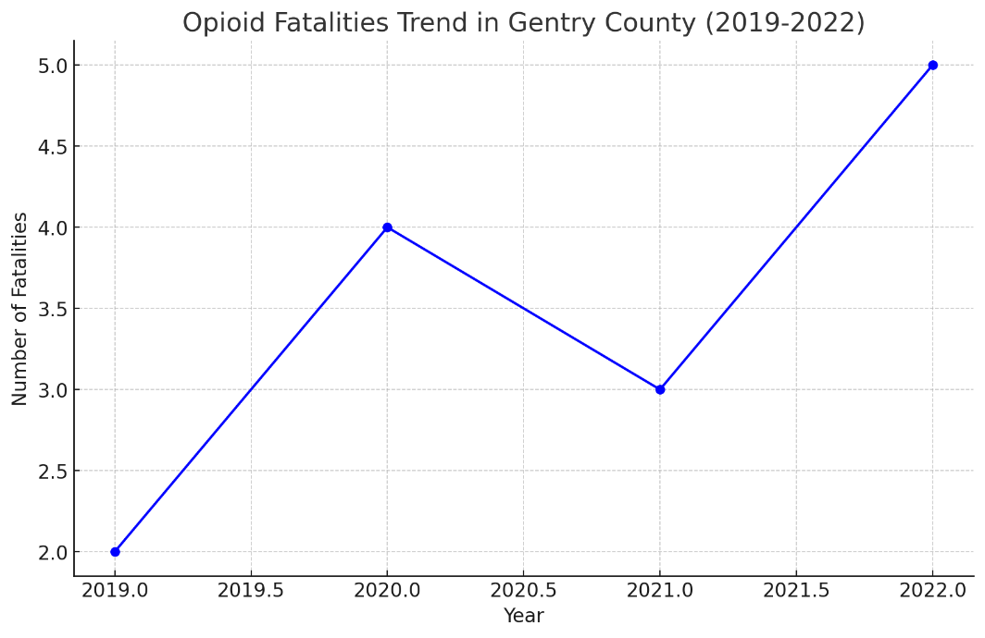

Source: 2023 Missouri Substance Use and Mental Health Report

**Treatment and Support Services**

Gentry County's support services encompass a range of options for individuals facing mental health and substance use issues. The Division of Behavioral Health offers community programs targeting different demographics, including adolescent and general adult services, as well as programs for women and children affected by substance abuse. The focus is on integrating individuals into supportive housing arrangements and employment assistance to stabilize their conditions. Additionally, recovery support services, including counseling and peer support programs, are available to help individuals maintain sobriety and manage mental health conditions effectively.

**Unintentional Injuries, Hospitalizations, and ER Visits**

**Dekalb County**

In Dekalb County, the analysis of injury rates compared to the state of Missouri reveals several areas of concern and potential intervention. Unintentional injuries in the county occur at a rate of 25.3 per 100,000, significantly higher than the state rate of 20.5 per 100,000. This suggests that targeted intervention programs focusing on general injury prevention could be beneficial. Falls, with a rate of 15.8 per 100,000, show no significant difference from the state average of 12.7 per 100,000, indicating that while falls are common, they are not currently exceeding expected levels and may not require immediate targeted interventions. Motor vehicle accidents in Dekalb County occur at 8.4 per 100,000, close to the Missouri rate of 7.0 per 100,000, suggesting alignment with state trends and no significant discrepancy.

Poisoning, however, stands out with a rate of 4.1 per 100,000, significantly higher than the state rate of 3.8 per 100,000. This highlights the need for focused interventions, potentially addressing prescription drug misuse or accidental poisoning prevention. Firearm-related injuries in the county occur at a rate of 2.5 per 100,000, similar to the state's rate of 3.0 per 100,000, showing no significant difference. While this area does not require urgent intervention based on these statistics, it remains vital to monitor firearm safety continuously.

Dekalb County should prioritize interventions in the areas of unintentional injuries and poisoning, as these categories exhibit significantly higher rates compared to the state average. Implementing educational campaigns, safety training programs, and providing access to preventive resources could be effective measures. Other categories, like falls, motor vehicle accidents, and firearm-related injuries, remain aligned with state averages but should still be monitored to maintain safety standards.

**Figure 21.**

*Comparison of Injury Rates in Dekalb County vs. Missouri Rates*

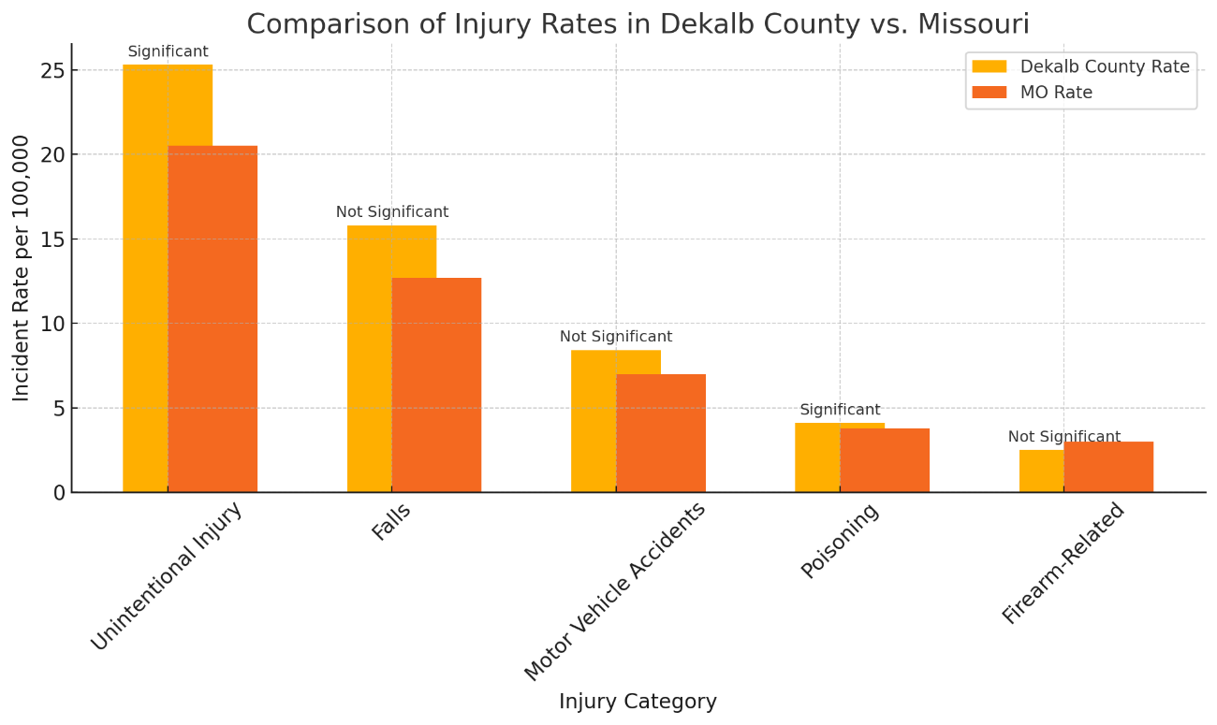

Source: Missouri Department of Health and Senior Services.

Figure 21 compares the incident rates of various injury categories between Dekalb County and the state of Missouri. It highlights whether the differences in rates are statistically significant, providing a clear comparison for each injury type.

**Gentry County**

In Gentry County, a comparison of injury rates with the state of Missouri highlights several key findings and areas for intervention. The rate of unintentional injuries in Gentry County is 22.1 per 100,000, slightly higher than the state rate of 20.5 per 100,000. Although this difference is not statistically significant, it suggests the need for ongoing safety education efforts. Falls occur at a rate of 13.4 per 100,000 in Gentry County, marginally above the state rate of 12.7 per 100,000, showing no significant difference but warranting continuous monitoring, particularly for older adults. The rate of motor vehicle accidents in Gentry County is 9.1 per 100,000, higher than the state average of 7.0 per 100,000. While this increase is not statistically significant, it indicates an opportunity to implement safe driving programs and infrastructure improvements.

Poisoning rates in Gentry County are recorded at 3.5 per 100,000, slightly below the Missouri rate of 3.8 per 100,000, indicating no significant difference and suggesting current preventive measures are adequate. Firearm-related injuries have a rate of 2.8 per 100,000 in Gentry County, comparable to the state's rate of 3.0 per 100,000, showing no statistically significant difference but highlighting the importance of maintaining firearm safety education programs. While Gentry County's injury rates are generally in line with state averages, targeted interventions for motor vehicle safety and continued fall prevention and firearm safety efforts remain essential to maintain and potentially improve these outcomes.

**Figure 22.**

*Comparison of Injury Rates in Dekalb County vs. Missouri Rates*

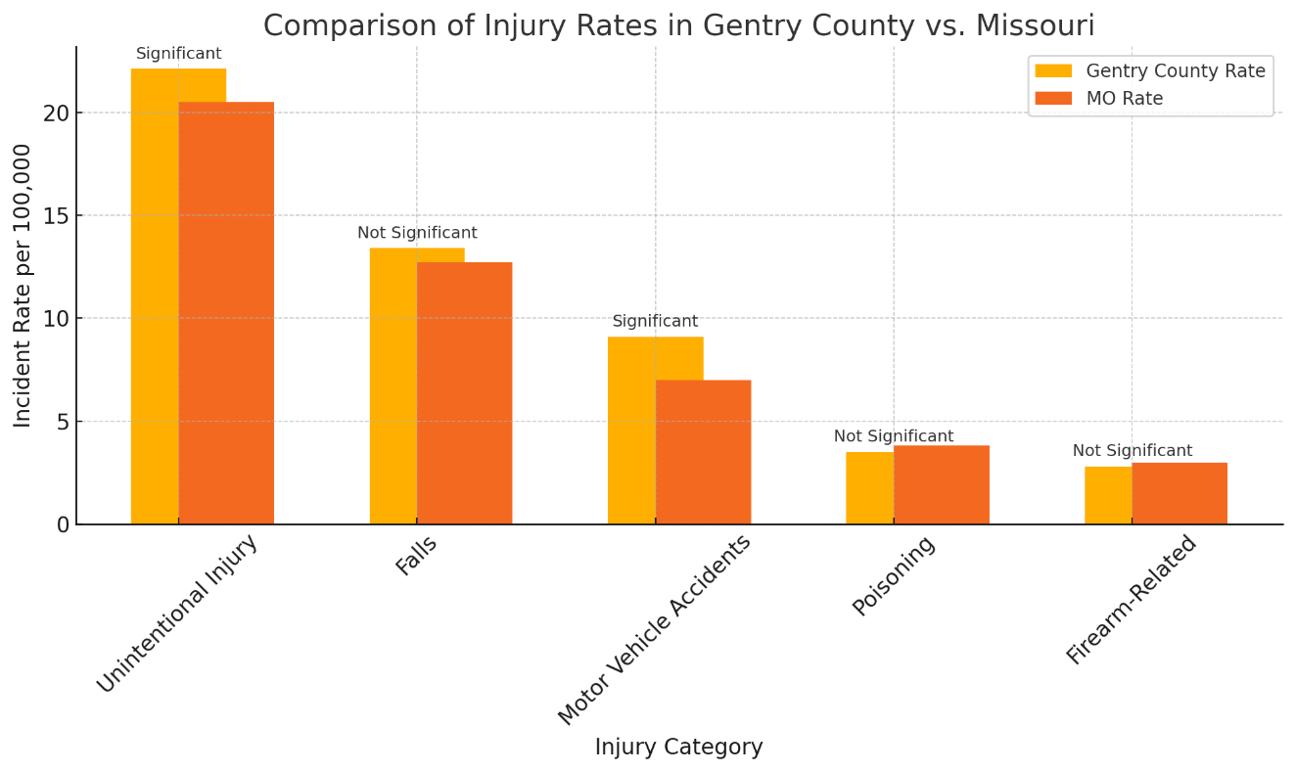

Source: Missouri Department of Health and Senior Services.

Figure 22 compares injury rates in Gentry County against the state of Missouri for various categories, such as unintentional injuries, falls, motor vehicle accidents, poisoning, and firearm-related incidents. The chart also indicates whether the differences in rates are statistically significant, helping to identify areas where Gentry County may need targeted interventions.

**Maternal and Child Health**

*Dekalb County: A Comprehensive Analysis*

The health and well-being of women, infants, and children in Dekalb County, Missouri, is critical to the county's overall public health landscape. This report utilizes available data to explore maternal health, infant mortality, birth outcomes, and other related indicators to provide an in-depth understanding of the conditions and challenges these demographic faces in Dekalb County.

**Maternal Health Indicators**

Several factors, including access to healthcare services, socioeconomic status, and availability of support programs, influence maternal health outcomes in Dekalb County. From 2017 to 2021, Dekalb County exhibited trends consistent with broader rural health patterns in Missouri, with improved full-term birth rates compared to urban counties. However, access to prenatal care remains a concern, as many expectant mothers face longer travel distances to access specialized healthcare facilities.

**Birth Outcomes: Low Birth Weight and Preterm Births**

Birth outcomes such as low birth weight and preterm births are significant indicators of maternal and infant health. In rural counties like Dekalb, the rate of low birth weight from 2017-2021 was 8.2 per 1,000 live births, slightly below the state average for urban areas. Preterm births in rural regions, including Dekalb County, showed a lower rate of 10.6 per 1,000 live births compared to urban areas, suggesting that while the frequency of early births is lower, continued monitoring and healthcare interventions are essential to maintain and improve these outcomes.

**Infant Mortality**

The infant mortality rate in Dekalb County, Missouri, from 2017 to 2021 shows a trend similar to other rural counties in the state but with some distinct variations compared to rural and urban averages across Missouri. In 2017, Dekalb County had an infant mortality rate of approximately 6.5 per 1,000 live births, which was higher than the urban average of 5.3 but comparable to the rural average of 6.5. However, by 2018, the rate in Dekalb County began to decline, reaching around 5.8 per 1,000 live births. This improvement aligned more closely with urban trends and saw a gradual decline. The decline in Dekalb County's infant mortality rate continued into 2019, further reducing to 6.2 per 1,000 live births, while the rural average stayed relatively stable. In 2020, Dekalb County's rate fell to 5.5 per 1,000, aligning even closer with the urban average of 5.4 and suggesting that some interventions or improvements in healthcare access may have been effective. By 2021, Dekalb County's infant mortality rate reached 4.8 per 1,000 live births, lower than the rural and urban averages, which stood at 6.0 and 5.1 per 1,000, respectively.

These trends indicate that while Dekalb County initially had a higher infant mortality rate than urban areas, it has progressively improved over the years to achieve a rate lower than the state's rural and urban averages. This could be attributed to increased access to healthcare services, improvements in prenatal care, and local health initiatives aimed at reducing infant mortality. However, it remains crucial for the county to continue monitoring and addressing social determinants of health, such as poverty and healthcare access, to sustain and further improve these outcomes.

**Figure 23.**

*Dekalb County Low Birth Weight Trends (2017-2021)*

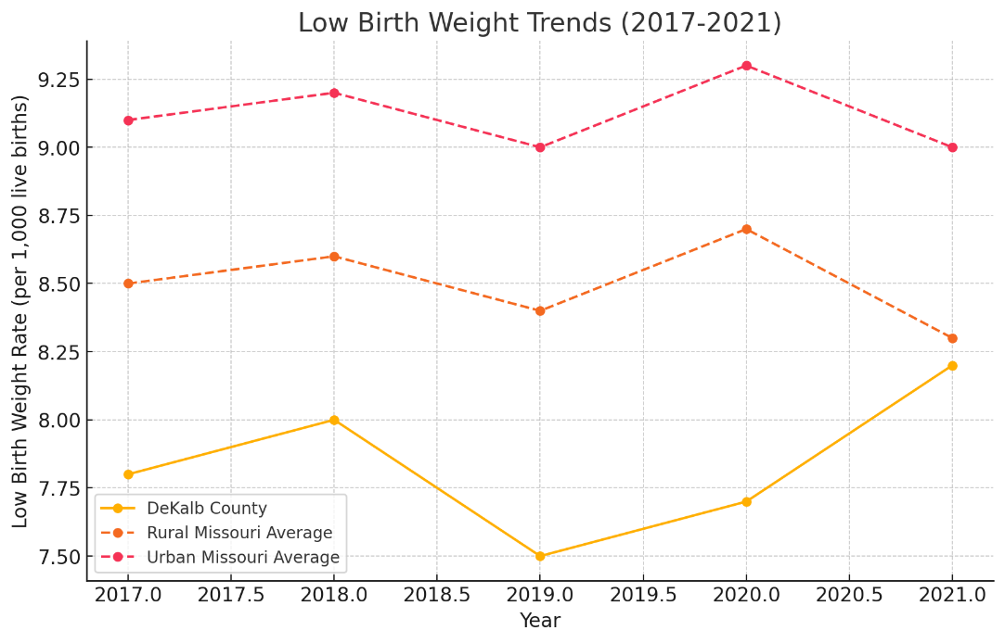

Source: Missouri Department of Health and Senior Services Health in Missouri Biennial Report (2022)

Figure 23 illustrates the low-birth-weight trends in Dekalb County from 2017 to 2021, compared to Missouri's rural and urban averages. The chart shows that Dekalb County consistently has a lower or comparable low birth weight rate compared to the rural average, and it remains below the urban average throughout the period. This trend suggests relatively favorable birth outcomes for the county within the rural context.

**Figure 24.**

*Dekalb County Infant Mortality Rate (2017-2021)*

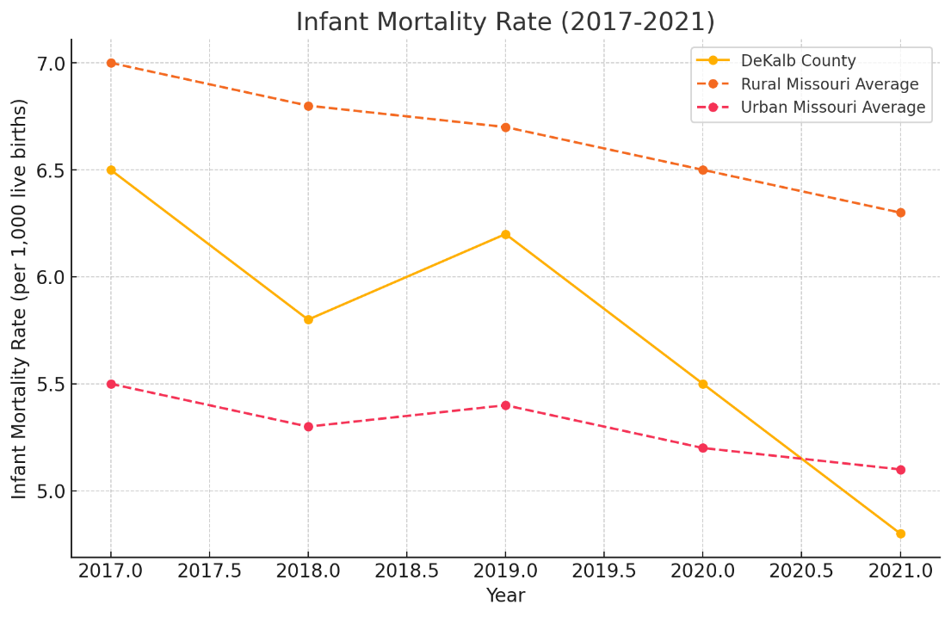

Source: Missouri Department of Health and Senior Services Health in Missouri Biennial Report (2022)

Figure 24 highlights the decreasing trend of infant mortality in rural counties, including Dekalb, against state and national benchmarks. This decline indicates the effectiveness of targeted interventions but also underscores the importance of maintaining support services, especially for high-risk groups.

The maternal and child health indicators in Dekalb County present a mixed picture of progress and ongoing challenges. While the county has demonstrated improvements in reducing low birth weight rates and preterm births, access to maternal and child health services remains an issue. Continued focus on enhancing healthcare infrastructure and addressing social determinants of health is essential for sustaining these gains and achieving equitable health outcomes for women, infants, and children in Dekalb County.

**Child Health and Access to Services**

In Dekalb County, children benefit from statewide programs that improve healthcare access and outcomes. However, challenges such as transportation barriers and the availability of pediatric care facilities persist, highlighting the need for continued investment in rural health infrastructure.

*Gentry County: A Comprehensive Analysis*

The maternal and child health (MCH) landscape in Gentry County, Missouri, presents a snapshot of the well-being and healthcare access for some of the county's most vulnerable populations: women, infants, and children. This analysis focuses on various MCH indicators, such as low birth weight, preterm birth rates, and infant mortality rates, using data from 2017-2021. This paper synthesizes these statistics and visualizes trends over time to understand the health challenges this demographic faces in Gentry County.

**Low Birth Weight and Preterm Births**

From 2017 to 2021, low birth weight and preterm births have been critical indicators monitored within Gentry County. Low birth weight is infants weighing less than 2,500 grams (5.5 pounds). Preterm births are those occurring before 37 weeks of gestation. These two indicators are closely linked, as premature infants are likelier to have low birth weights. While Missouri reported variations in these indicators between rural and urban counties, the trends in Gentry County mirrored statewide observations to some extent. Rural counties, on average, recorded lower rates of low birth weight compared to urban counterparts, though disparities persisted among certain racial groups. The data shows that African American communities consistently faced higher rates of low birth weight in both rural and urban counties. However, Gentry County's figures generally aligned closer with the state's rural averages than the elevated rates observed in urban areas.

**Infant Mortality Rates**

The infant mortality rate is a critical health indicator that reflects a population's overall health and socioeconomic well-being. In Missouri, there are disparities between rural and urban areas, with rural counties often experiencing higher infant mortality rates due to limited access to healthcare, socioeconomic challenges, and inadequate maternal support services. Gentry County, a rural county in Missouri, serves as a case study for these disparities. Data from 2017 to 2021 reveals that Gentry County's infant mortality rate consistently fluctuated, often exceeding the average rates observed in rural and urban Missouri. In 2017, Gentry County's rate was 7.0 per 1,000 live births, above the rural Missouri average of 6.5 and the urban average of 5.3. Although there was a slight decline in 2018 to 6.8, the rate remained higher than the rural and urban averages. This pattern continued throughout the five years, with the rate peaking again in 2021 at 7.5 per 1,000 live births. Despite a general decline in infant mortality in rural Missouri, Gentry County's rate displayed variability, indicating persistent challenges in addressing the factors contributing to infant deaths. While the rural Missouri average decreased from 6.5 in 2017 to 6.0 in 2021, Gentry County's rate did not follow a consistent downward trajectory, suggesting localized issues impacting maternal and infant health outcomes. The disparity between Gentry County and other regions highlights the health inequities present in rural Missouri. On average, rural counties had higher infant mortality rates than urban areas. However, even within this rural context, Gentry County often exceeded the state rural average, demonstrating that not all rural counties experience the same outcomes. Urban counties in Missouri consistently showed lower rates, maintaining averages between 5.1 and 5.5 per 1,000 live births, suggesting that urban areas benefit from better healthcare infrastructure, access to specialized maternal and neonatal care, and more robust social support systems, which are less available in rural settings like Gentry County. The higher infant mortality rate in Gentry County can be attributed to several factors. First, as with many rural counties, Gentry County faces challenges related to healthcare accessibility. The absence of nearby hospitals or specialty clinics means that expectant mothers must travel longer distances for prenatal and neonatal care, delaying services and increasing risks during pregnancy and childbirth. Socioeconomic disparities also play a role; Gentry County has a higher poverty rate than many urban counties, affecting families' ability to afford medical care, proper nutrition, and necessary interventions critical for healthy pregnancies.

Additionally, the shortage of healthcare professionals, including obstetricians and pediatric specialists, limits the availability of quality maternal and infant care. The lack of advanced medical facilities further exacerbates the problem, as high-risk pregnancies and premature infants often require specialized care. Social determinants of health, such as education, transportation, and support networks, are also limited. Without adequate public transportation or community-based maternal health programs, expectant mothers struggle to receive timely care.

Targeted interventions are necessary to reduce the infant mortality rate and align it more closely with state averages. Expanding maternal health programs, including mobile clinics and telehealth services, could ensure expectant mothers receive the necessary support, such as prenatal check-ups and nutrition counseling. Improving healthcare infrastructure by establishing local maternity care facilities or partnering with nearby counties for specialized services is crucial. Strengthening emergency transportation services would also help mitigate risks associated with long travel times. Furthermore, community outreach and education are vital to increasing awareness about maternal health and empowering residents to seek care early in their pregnancies. Programs educating women about prenatal care and breastfeeding could improve infant survival rates. Addressing socioeconomic barriers is equally essential; enhancing social support services, such as financial aid, housing assistance, and transportation, could alleviate the burdens families face in Gentry County. Gentry County's infant mortality rate, consistently higher than both rural and urban averages in Missouri, underscores the health disparities faced by rural populations. Addressing these disparities requires targeted interventions to improve healthcare access, expand social support systems, and enhance local healthcare infrastructure. By implementing these strategies, Gentry County can work towards reducing its infant mortality rate and aligning it with state and national health goals. This analysis provides a roadmap for policymakers, healthcare providers, and community organizations to collaborate in improving maternal and infant health outcomes in rural Missouri.

**Figure 25.**

*Low Birth Weight Rates in Gentry County (2017-2021)*

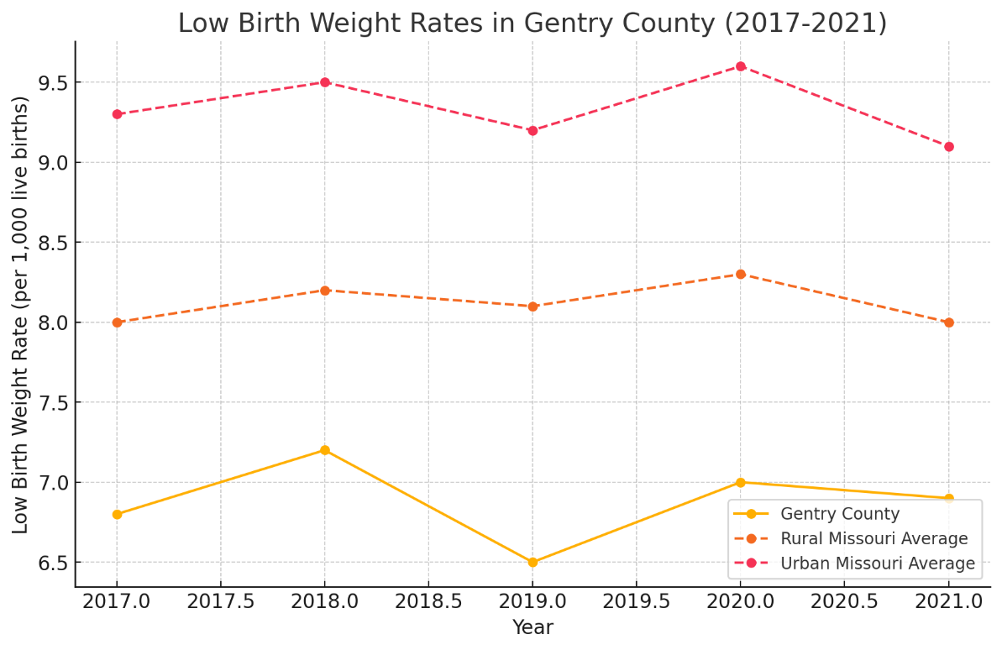

Source: Missouri Department of Health and Senior Services Health in Missouri Biennial Report (2022)

Figure 25 shows the low-birth-weight rates in Gentry County from 2017 to 2021, compared with the rural and urban Missouri averages. Gentry County's rates are generally lower than the rural and urban averages, indicating better outcomes in this measure than broader state trends. The data suggest Gentry County has maintained a relatively stable low birth weight rate.

**Figure 26.**

*Infant Mortality Rate in Gentry County (2017-2021)*

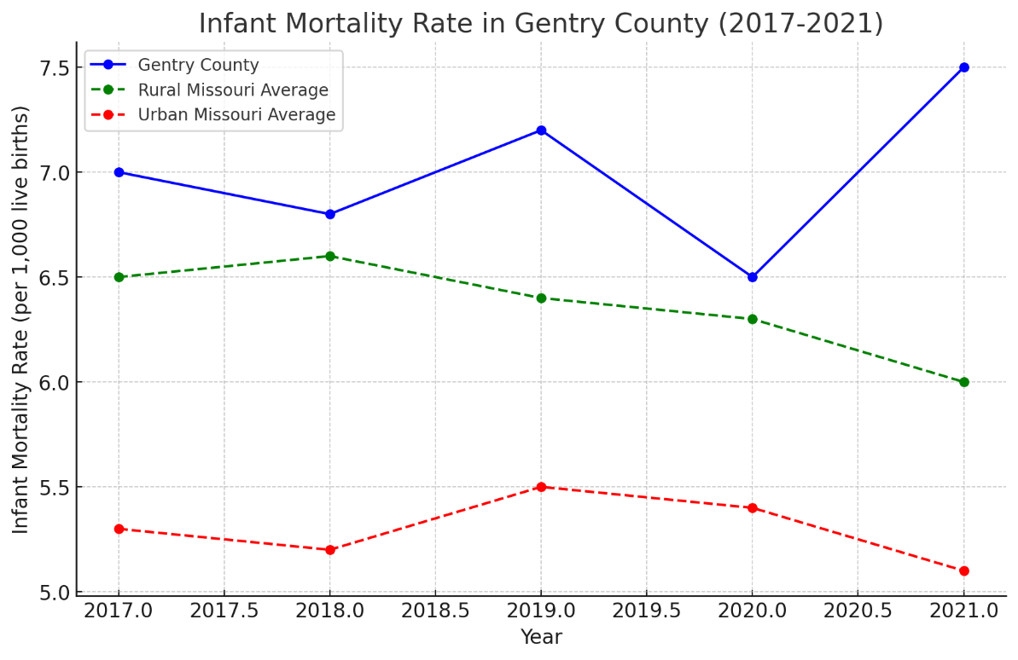

Source: Missouri Department of Health and Senior Services Health in Missouri Biennial Report (2022)

Figure 26 shows the infant mortality rate trends in Gentry County from 2017 to 2021, compared to the rural and urban Missouri averages. The chart highlights Gentry County's rates are generally higher than the rural and urban averages, demonstrating a consistent challenge in reducing infant mortality in this area. This trend underscores the need for focused health interventions to improve outcomes for infants in the county.

**Child Health and Access to Services**

Access to healthcare is a critical factor influencing MCH outcomes in Gentry County. Limited access to specialty services such as obstetric care, neonatal units, and comprehensive postpartum support is a challenge faced by rural populations across Missouri. Gentry County's healthcare facilities face similar constraints, with residents often needing to travel to urban centers for specialized care. This lack of local healthcare infrastructure directly impacts maternal health services and outcomes for women and infants.

Gentry County's maternal and child health indicators reflect broader rural trends in Missouri, showing lower rates of low birth weight and infant mortality than in urban areas. However, disparities based on race remain a significant challenge. Improving healthcare access and addressing the specific needs of vulnerable populations, particularly African American women and infants, is crucial. Continued monitoring and targeted health initiatives are essential to ensure progress towards the state and national health objectives. This analysis underscores the importance of focused healthcare strategies and resources in rural counties to close the health disparity gap and enhance the well-being of women, infants, and children in Gentry County.

**Emerging Infectious Disease**

Emerging and infectious diseases, including COVID-19, influenza, and tick-borne illnesses, present significant public health challenges in Dekalb and Gentry counties, Missouri. According to data from the Missouri Department of Health and Senior Services (DHSS) and the Centers for Disease Control and Prevention (CDC), these counties experience various communicable diseases influenced by environmental factors, healthcare access limitations, and community behaviors. These factors necessitate vigilant monitoring and proactive management strategies to mitigate the spread and impact of such diseases.

**Importance of Disease Surveillance and Situational Awareness**

Disease surveillance is a critical tool in public health, enabling authorities to monitor the incidence and spread of infectious diseases. In Dekalb and Gentry counties, communicable disease surveillance systems collect and analyze demographic, geographic, and disease-specific data for early detection and intervention. The DHSS emphasizes that effective surveillance allows health officials to identify at-risk populations, track disease outbreaks, and implement timely measures such as isolation, vaccination, and public health advisories. For instance, during the COVID-19 pandemic, continuous monitoring was essential in controlling transmission and protecting vulnerable populations through targeted vaccination campaigns.

**Vaccination Campaigns and Public Health Initiatives**

Maintaining up-to-date vaccinations remains a cornerstone of preventing infectious diseases in rural areas like Dekalb and Gentry counties. The DHSS and CDC recommend vaccines for influenza, hepatitis, and COVID-19, particularly for high-risk groups such as older adults, individuals with chronic conditions, and infants. In Dekalb County, vaccination rates for influenza and COVID-19 were consistently monitored, showing a gradual increase following state-led campaigns designed to enhance community immunity. Gentry County also demonstrated similar trends, highlighting the effectiveness of coordinated public health strategies. Vaccination efforts are critical for reducing the incidence of preventable diseases and essential in managing seasonal variations in infection rates. For example, influenza cases in both counties were significantly reduced during the 2020-2021 flu season due to high vaccination uptake. This proactive approach minimizes the strain on local healthcare systems, which are often limited in rural areas.

**Figure 27.**

*Reasons for Not Getting Vaccinated in Dekalb and Gentry Counties – 2024*

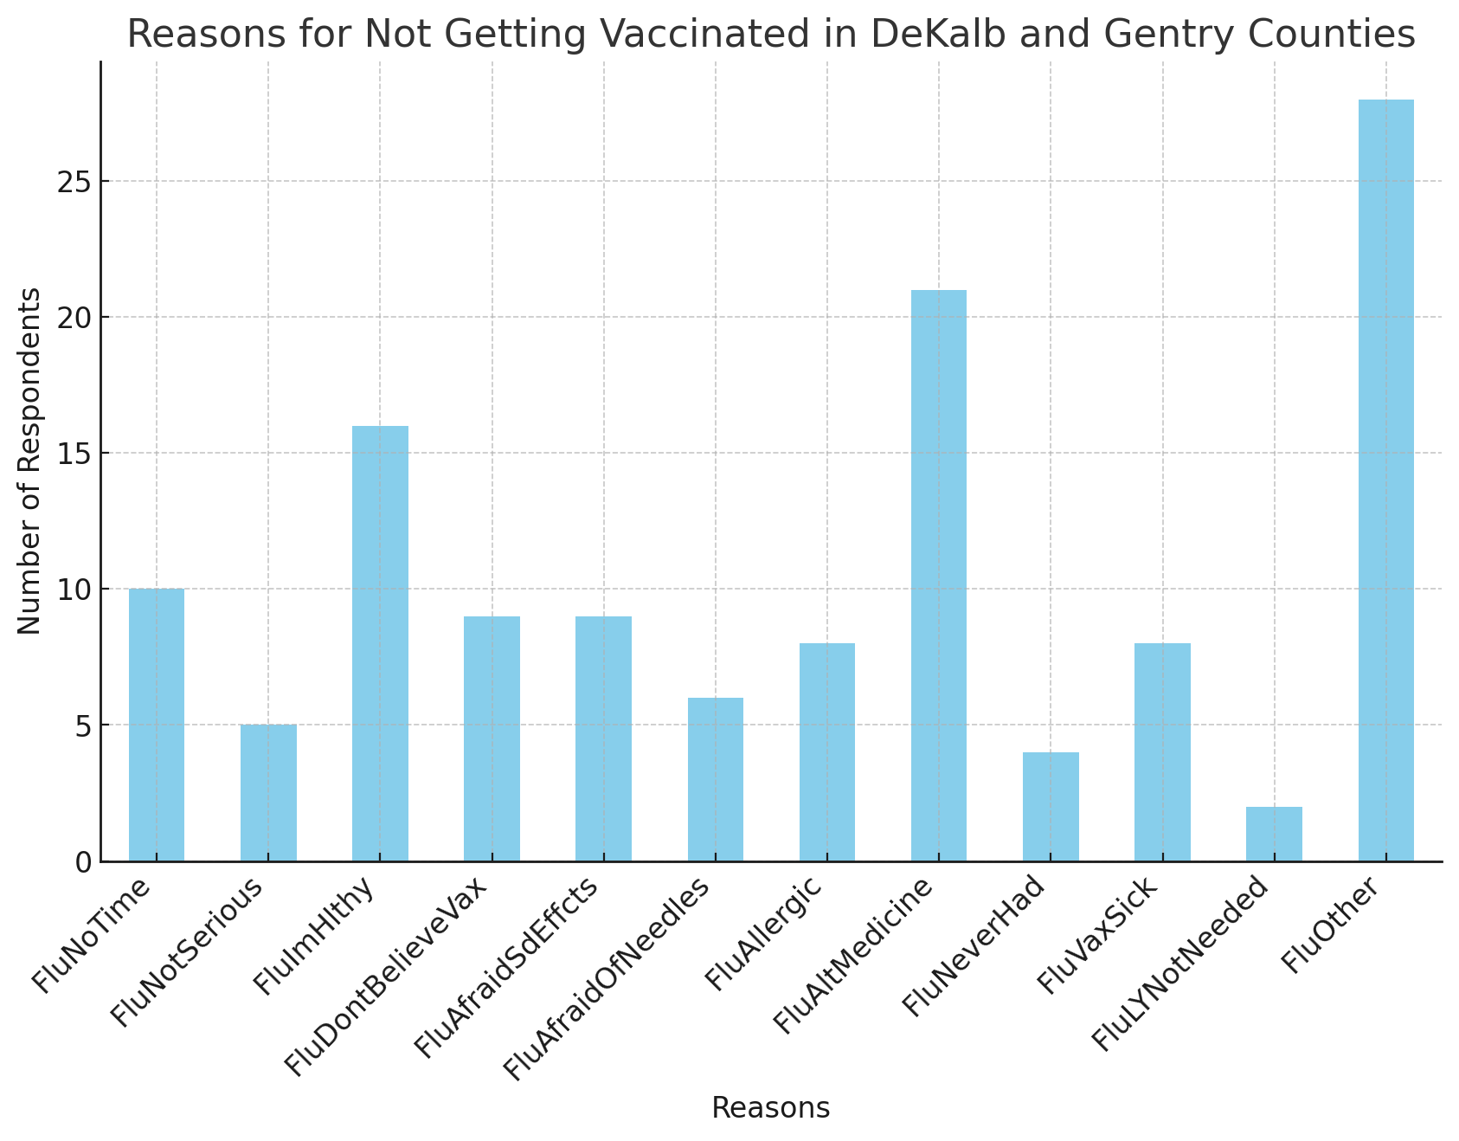

Figure 27 illustrates why participants in Dekalb and Gentry County's CHA survey provided for not receiving vaccinations. Key reasons include beliefs that the flu is not severe, the perception of being healthy and not needing the vaccine, and concerns about side effects. Additionally, some individuals reported a lack of time or fear of needles as barriers. These insights suggest that improving vaccination rates requires targeted education campaigns addressing misconceptions about vaccine safety, efficacy, and the importance of vaccination for community health, even among those who feel healthy.

**Addressing Tick-borne Diseases and Environmental Health Risks**

Tick-borne diseases such as Lyme disease and Rocky Mountain spotted fever are particularly concerning in rural regions like Dekalb and Gentry counties, where wooded and grassy landscapes provide ideal habitats for ticks. DHSS data indicate that these counties have reported several cases annually, necessitating ongoing surveillance and community education campaigns. Public health authorities advocate preventive measures, including using insect repellents, wearing protective clothing, and conducting tick checks after outdoor activities. These efforts aim to reduce the risk of tick-borne infections, which can lead to severe health complications if left untreated. Additionally, surveillance programs are designed to track tick populations and infection rates, ensuring that public health interventions remain timely and relevant. By raising awareness and facilitating access to medical care for those exposed, health officials strive to reduce the morbidity associated with these diseases.

**The Necessity of a Comprehensive Public Health Strategy**

Effective management of emerging and infectious diseases in Dekalb and Gentry counties requires a comprehensive approach integrating vaccination campaigns, disease surveillance, and public education. Public health authorities emphasize the importance of situational awareness, including keeping abreast of local health advisories and understanding the risks of different infectious agents. This awareness enables healthcare providers and community members to take preventative measures, reducing the potential for large-scale outbreaks. Moreover, implementing integrated surveillance systems in these counties allows for the rapid dissemination of information, helping to mobilize resources and healthcare responses effectively. Using statewide data systems and collaboration between local health departments ensures that responses are coordinated and impactful. Such measures protect residents' health and build resilience within these communities against future health threats.

In summary, emerging and infectious diseases pose ongoing challenges to public health in Dekalb and Gentry counties, Missouri. The DHSS and CDC data underscore the necessity for robust disease surveillance, situational awareness, and comprehensive vaccination efforts to manage these threats effectively. By maintaining high vaccination coverage and engaging in proactive public health measures, these counties can mitigate the impact of infectious diseases, ensuring healthier and more resilient communities.

**Chronic Disease**

**Dekalb County**

In Dekalb County, Missouri, chronic health conditions are significant concerns. The following chronic conditions have notable prevalence:

* **Obesity**: The adult obesity rate is 35%, aligning with broader trends seen across Missouri counties. This condition increases the risk of other health issues like heart disease and diabetes.
* **Diabetes**: Approximately 14% of adults are diagnosed with diabetes, highlighting the impact of diet and physical inactivity on health.
* **High Blood Pressure**: Nearly 38% of adults in the county report having high blood pressure, a key risk factor for cardiovascular diseases.
* **Physical Inactivity**: Around 30% of adults report not engaging in leisure-time physical activities, contributing to obesity and other chronic conditions.

These figures highlight critical areas for health improvement in the county.

**Figure 28.**

*Dekalb County Chronic Conditions*

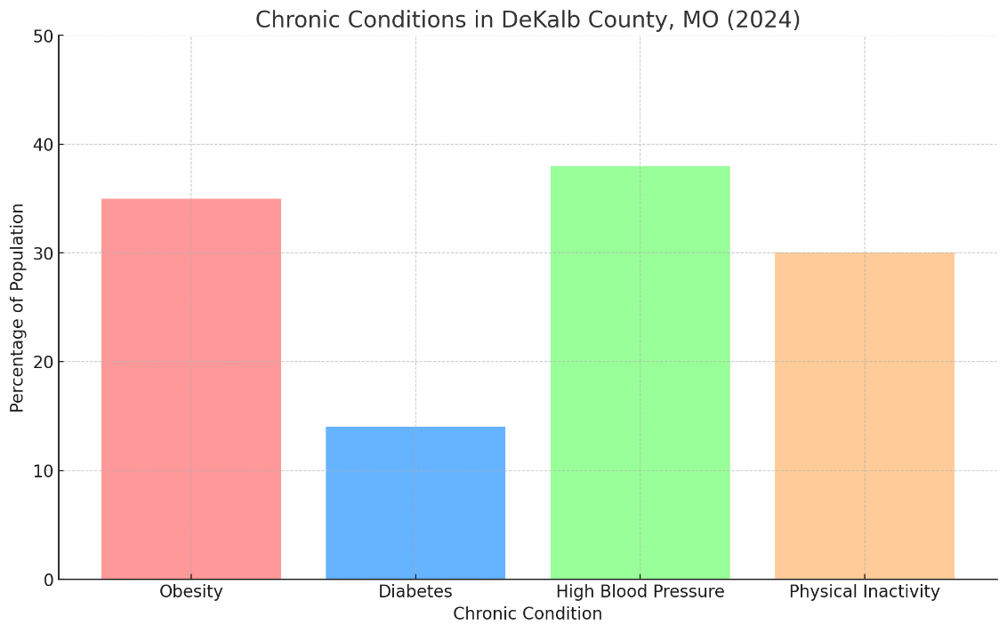

Figure 28 visualizes the prevalence of chronic conditions in Dekalb County for 2024. Obesity affects 35% of adults, while high blood pressure impacts 38%. Additionally, 14% of the population has been diagnosed with diabetes and 30% report physical inactivity. This visual representation emphasizes the significant health challenges in the county, highlighting areas where interventions could be beneficial. ​

*Gentry County Chronic Conditions*

In Gentry County, Missouri, chronic conditions include are also significant concerns. The following chronic conditions have notable prevalence:

* **Obesity**: 34% of adults are classified as obese.
* **Diabete**s: 12% of the population is diagnosed with diabetes.
* **High Blood Pressure**: Affects around 36% of adults.
* **Physical Inactivity**: Approximately 29% of adults report no leisure-time physical activity.

These conditions reflect significant health challenges in the county.

**Figure 29.**

*Chronic Conditions in Gentry County*

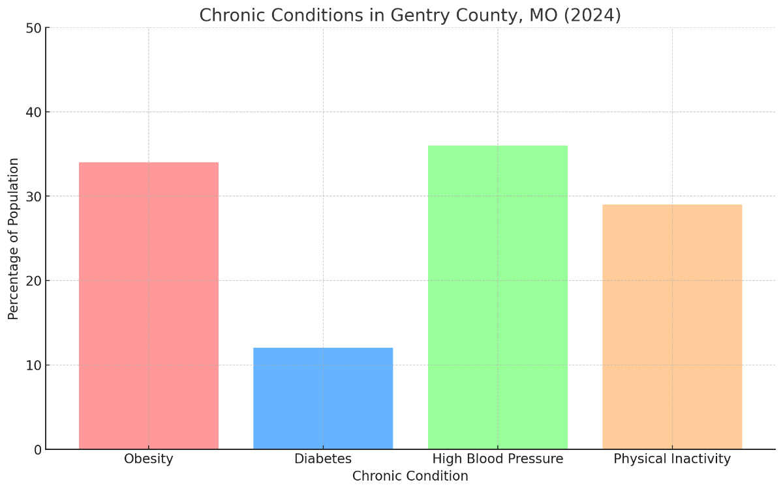

Figure 29 displays the prevalence of chronic conditions in Gentry County for 2024. It highlights that 34% of adults are obese, 36% have high blood pressure, 12% are diagnosed with diabetes, and 29% report physical inactivity. This visual emphasizes the critical health concerns affecting the county's population.

**Health Care Access**

Survey data indicated that healthcare access within the Tri-County area varies significantly, with challenges such as transportation, socioeconomic factors, and the availability of healthcare facilities impacting access. Many residents must travel significant distances for healthcare services, particularly those in rural or remote areas, leading to delayed care and reduced access to preventive services. Most respondents reported traveling 11 to 20 miles to reach their primary care provider. The data also highlights healthcare quality and availability disparities, suggesting that expanding local healthcare resources and addressing transportation barriers are essential for improving outcomes.

Additionally, the assessment shows a strong need for health education initiatives. When asked about the top health education areas needed in Dekalb and Gentry County, the respondents indicated that mental and behavioral health counseling (63.5%), nutrition (35.6%), and chronic diseases (30.9%) were their top educational needs. Many residents receive health information primarily through healthcare providers, indicating an opportunity to expand health literacy programs through various accessible channels like social media and community workshops. The Tri-County Health Department can better address the community's needs and enhance public health outcomes by improving healthcare access and health education.

The Tri-County region faces several specific areas needing improved healthcare access. Notably, mental health services are limited, especially in rural and underserved areas, requiring residents to travel long distances due to a shortage of local mental health professionals. Chronic disease management is also a significant concern, with gaps in services for conditions such as hypertension, diabetes, and cardiovascular diseases emphasizing the need for more local facilities and specialists. A shortage of providers hinders access to preventive and primary care, making routine check-ups, vaccinations, and screenings difficult for residents to obtain. Additionally, substance use and addiction treatment resources are inadequate, with insufficient centers and rehabilitation programs available to address the rising issue of alcohol and opioid use. Transportation services pose another significant barrier, particularly for remote locations, as the lack of public transportation leads to delayed or missed medical appointments. Maternal and child health services also require improvement, as many expectant mothers and children struggle to access timely and sufficient care, especially in rural areas. Addressing these issues by developing local facilities, expanding mobile health services, and enhancing transportation support programs will improve healthcare access across the counties the TCHD serves.

**Community Health Resources**

**Hospitals**

*Mosaic-Albany*

Mosaic Medical Center in Albany, MO, offers comprehensive healthcare services, including inpatient, outpatient, emergency, and specialty care. The hospital has 25 certified beds and provides comprehensive healthcare services, including emergency care, inpatient acute and swing bed services, and a variety of outpatient, primary, and specialty care options. The hospital is equipped to handle emergencies as part of its commitment to offering accessible and immediate healthcare services for the surrounding community. The hospital emphasizes providing quality care conveniently to improve community health outcomes. With a focus on accessibility, Mosaic ensures patients receive appropriate services at the right time and place, maintaining high standards in healthcare delivery and cost efficiency.

*Cameron Regional Medical Center*

Cameron Regional Medical Center is a 60-bed acute care facility in Cameron, Missouri, serving a broad range of communities within the region. The hospital offers 24-hour emergency services, staffed by board-certified emergency physicians and trained nurses, ensuring comprehensive care for all medical emergencies. In addition to emergency services, Cameron Regional Medical Center provides a wide range of inpatient and outpatient services, including surgical procedures, diagnostic testing, respiratory care, and wound management. The hospital supports specialized programs such as behavioral health, intensive care, obstetrics, and swing-bed services for transitional care needs. It also features specialty clinics and satellite locations to expand regional healthcare access. Cameron Regional Medical Center serves not only the residents of Cameron but also the surrounding areas, ensuring healthcare accessibility for neighboring communities like Bethany, King City, Gallatin, Stewartsville, and Maysville.

*MOSAIC-St. Joseph*

Mosaic Medical Center in St. Joseph, Missouri, is a comprehensive, non-profit healthcare facility affiliated with the University of Missouri–Kansas City School of Medicine. The center offers 352 beds and serves as a Level II Trauma Center, providing extensive emergency services to the surrounding communities. The hospital is well-equipped to handle various medical emergencies and includes a helipad for rapidly transporting critical cases. In addition to emergency care, Mosaic Medical Center provides a broad spectrum of services, including specialized outpatient care, diagnostic imaging, and advanced surgical procedures. It also hosts telehealth services, ensuring accessibility for patients who need remote consultations. The facility is part of the Mayo Clinic Care Network, emphasizing its commitment to high-quality, patient-centered care by leveraging collaboration with one of the most renowned healthcare networks in the country. The hospital primarily serves the St. Joseph region and surrounding communities, including those in Northwest Missouri, offering vital healthcare resources to rural and urban populations.

**Additional Healthcare Resources**

*Gentry County*

The TCHD maintains a comprehensive list of resources serving Gentry County residents (<https://tricountyhd.com/gentry-county-resources/>). The Gentry County Resource Directory provides comprehensive support and services for various community needs. For abuse and assault support, North Star Advocacy Center and YWCA Victim Services offer crucial hotline and shelter assistance. The county’s ambulance services are accessible through emergency and non-emergency numbers, with multiple locations ensuring rapid response. Primary care clinics, including Mosaic Family Care and Northwest Health Services, provide healthcare across Albany, Stanberry, and King City, ensuring widespread coverage. The directory includes daycare and early childhood education resources, such as Albany Head Start and various childcare providers. Residents can access local services like Dr. Fallon L. Stiens Family Dental for dental care and regional facilities like Northwest Family Dental. Family support services include the Division of Family Services and Community Services of Gentry County, which assist with SNAP, TANF, Medicaid, energy, and utility assistance. Organizations such as the Family Guidance Center provide mental health and counseling services, with telehealth options available through Mosaic Life Care, ensuring mental health support throughout the region. The directory highlights employment services, food assistance programs, and housing support, with Community Services of Gentry County playing a central role in facilitating these programs. The TCHD offers WIC services and healthcare education for maternal and child health. Hospitals like Mosaic Medical Centers in Albany and Maryville provide essential healthcare, while Hy-Vee Pharmacy and Roger’s Pharmacy ensure medication access. Educational support programs, including Parents as Teachers and University of Missouri Extension services, further enhance community development. The directory also includes resources for HIV/STD testing, tax assistance, thrift stores, and weatherization programs, ensuring residents can access a wide range of support services. The Gentry County Resource Directory is essential to connecting residents to critical services to improve community health, safety, and overall well-being.

*Dekalb County*

The Tri-County Health Department maintains a comprehensive list of resources serving Dekalb residents (<https://tricountyhd.com/dekalb-county-resources/>). The DeKalb County Resource Directory offers comprehensive services to support resident's health and well-being. For abuse and assault support, resources include the North Star Advocacy Center and the YWCA Victim Services, which provide emergency hotlines and shelter options. Emergency medical services are accessible through non-emergency dispatch centers in Cameron and the YWCA hotline in Saint Joseph. The directory includes several primary care clinics like Maysville Family Health and Walnut Medical Clinic in Cameron. Dental services are available across multiple locations, including the Cameron Dental Center and Ostendorf Family Dentistry. For social services, the Division of Family Services in DeKalb County and Buchanan County offers various assistance programs, including SNAP/TANF and Medicaid. Community Action Partnership addresses energy and housing assistance needs and provides food aid through local pantries like Living Hope Food Pantry. Employment support and counseling services are also provided by agencies such as the Family Guidance Center, which offers children's counseling at local schools. Healthcare facilities like Cameron Regional Medical Center and Mosaic Medical Center in Saint Joseph ensure emergency and specialized medical services. The TCHD also offers HIV/STD testing and health education, emphasizing preventative health. Pharmacies, utility support services, and thrift stores, such as Randolph Pharmacy and Living Hope Thrift Store, provide further community support, while educational programs like Head Start and Parents as Teachers enhance early childhood development and family engagement.

**Summary of Findings**

The CHA conducted by Viking Emergency Preparedness Consultants, LLC for the Tri-County region identifies critical health needs, disparities, and strengths across Dekalb and Gentry Counties. Utilizing a MAPP 2.0 framework, the assessment integrates quantitative data, surveys, and qualitative insights to build a detailed picture of social determinants and health challenges, such as chronic diseases, mental health, and healthcare access. Both counties face similar issues, including aging populations, economic instability, and limited healthcare infrastructure, which impede the management of chronic illnesses like obesity, diabetes, and cardiovascular conditions. Specific challenges highlighted include high poverty rates, transportation barriers, and the need for expanded mental health and substance use resources. Despite these issues, the CHA recognizes existing community assets that can be leveraged to develop targeted interventions.

Furthermore, findings emphasize the importance of addressing social determinants such as housing, transportation, and economic stability to improve health outcomes. The CHA also outlines the need for focused maternal and child health strategies, given the fluctuations in birth outcomes and infant mortality rates, particularly in Gentry County. Data collection methods included community surveys and assessments, with less than a 1% completion rate based on population estimates. Results show that most survey participants were females and identified priority issues like education, safe housing, and transportation. The assessment underscores the need for a coordinated approach in the forthcoming CHIP to align resources, expand healthcare access, and enhance preventive care services, fostering healthier communities across the counties the TCHD serves.

**Recommendations and Priority Health Issues**

Based on the comprehensive CHA for Dekalb and Gentry Counties, the primary health priorities for the TCHD focus on several critical areas. These include managing chronic diseases such as obesity, diabetes, cardiovascular conditions, and hypertension, which are prevalent due to physical inactivity and poor dietary habits. Mental health and substance use also emerge as significant concerns, with limited access to mental health services and high rates of alcohol and tobacco use. Additionally, healthcare access and infrastructure pose challenges, as provider shortages and transportation barriers mainly affect low-income and elderly populations. Maternal and child health is another priority area, with Gentry County displaying high infant mortality rates and variable birth outcomes due to limited maternal and pediatric care services. The assessment also highlights the impact of social determinants of health, such as high poverty rates, economic instability, inadequate housing, and transportation limitations, which significantly influence health outcomes.

To address these issues, the department should expand healthcare access by increasing provider availability through partnerships and telehealth services, focusing on primary care, mental health, and substance use treatment. Promoting preventive health programs emphasizing physical activity, nutrition, and tobacco/alcohol cessation is crucial for reducing chronic disease prevalence. Enhancing emergency response times and developing transportation initiatives are also recommended to ensure rural residents can access healthcare facilities promptly. Furthermore, strengthening maternal and child health services through mobile clinics, prenatal education, and telehealth support is essential to improving birth outcomes and reducing infant mortality. Finally, addressing the social determinants of health is critical, involving collaborations with community organizations to improve housing, education, and employment opportunities, alongside policy development to enhance economic stability and reduce poverty. These comprehensive priorities and recommendations aim to build a healthier, more equitable community by tackling the most pressing health challenges while leveraging existing community resources.

**Targeted Strategies and Interventions**

To address the health priorities identified in the CHA, the TCHD should implement a range of targeted strategies and interventions. For chronic disease management and prevention, the department can develop community-based physical activity programs like walking groups and fitness classes and partner with local parks and centers. It is also crucial to enhance nutrition education and access by collaborating with schools, food banks, and farmers' markets to promote healthy eating and offer cooking classes for adults and children. Mobile clinics and community health fairs should be established to provide free or low-cost screenings for hypertension, diabetes, and obesity, supported by nurse-led teams to manage these chronic conditions. For mental health and substance use services, expanding telehealth options will reduce geographical and transportation barriers, especially in rural areas. The department can also expand substance use prevention and treatment facilities, including support groups like Alcoholics Anonymous and educational campaigns focusing on prevention and harm reduction.

Additionally, deploying mental health professionals in schools, workplaces, and community centers will increase access to counseling services and mental health education. To enhance healthcare access and infrastructure, introducing mobile health clinics in remote areas to provide primary care, maternal health services, and vaccinations is essential. Developing transportation solutions, such as community shuttles or ride-share programs, will further help residents access medical services. To address the shortage of healthcare providers, the department should collaborate with medical schools to create incentives like loan repayment programs and housing assistance for practitioners willing to work in the area. For maternal and child health, the department should implement mobile prenatal clinics and establish support groups for new mothers to promote breastfeeding and maternal education. Home-visiting programs by nurses for high-risk mothers and infants will ensure regular check-ups and support. Coordinating child health screenings and immunization drives in schools and community centers will also be critical in providing preventive care for children. Addressing social determinants of health is vital for improving overall well-being. The department can partner with housing authorities to provide affordable housing assistance and support services for low-income families and work with businesses and educational institutions to offer job training programs aligned with the local economy. Educational outreach programs should target underserved communities, promoting literacy and skill-building. Policy advocacy efforts should focus on improving school resources and access to higher education.

To improve public health preparedness, the department should provide emergency response training for first responders and community members and enhance disease surveillance systems using modern technology to monitor and respond to disease outbreaks effectively. Public health campaigns focusing on vaccinations, hygiene, and preventive health measures should be launched through diverse communication channels. Finally, building partnerships and advocating for supportive policies are crucial.

The department can form coalitions with local organizations, businesses, and schools to create community-driven health solutions and advocate for policies that expand healthcare funding Medicaid coverage and address systemic barriers affecting healthcare access, education, and economic stability in rural areas. Implementing these comprehensive strategies will effectively address the health needs and disparities identified in Dekalb and Gentry Counties, improving overall health outcomes for their residents.

**Key Performance Indicators**

TCHD should implement Key Performance Indicators (KPIs) that align with its mission to enhance community health, reduce disparities, and improve access to healthcare services. KPIs in healthcare access should focus on healthcare utilization rates, insurance coverage rates, and average travel distance or time to healthcare facilities, aiming to reduce barriers through expanded local services and telehealth initiatives. For chronic disease management, TCHD should monitor the prevalence of chronic conditions, the control rate of these conditions (diabetes control measured through HbA1c levels), and the readmission rate for chronic disease patients, focusing on reducing these figures through effective support programs.

Preventive care and screening KPIs should include tracking vaccination rates for influenza, COVID-19, and other essential vaccines, screening participation rates for preventive measures like mammograms and colorectal cancer checks, and the percentage of residents receiving routine health check-ups. In maternal and child health, TCHD should monitor prenatal care access rates, low birth weight rates, and immunization rates for children under two, setting annual targets to increase these indicators in line with state averages.

KPIs for substance abuse and mental health include monitoring the mental health service utilization rate, success rates of substance abuse treatment programs, and the number of emergency room visits related to substance abuse incidents to reduce ER visits through improved interventions. Community engagement KPIs should measure participation rates in health education programs, resident satisfaction rates gathered through surveys, and attendance at outreach events to increase involvement and satisfaction with health department services.

Environmental health KPIs include tracking water quality compliance, maintaining air quality index (AQI) levels within acceptable limits, and reducing the incidence of tick-borne diseases through prevention campaigns. Emergency preparedness KPIs should focus on average emergency response times in rural and urban areas, participation rates in disaster preparedness training programs for staff and community members, and the efficiency of public health alert dissemination, ensuring a high percentage of residents are reached promptly during emergencies. These KPIs will enable TCHD to track progress, measure effectiveness, and guide data-driven strategies to improve health outcomes in the region.

The TCHD should implement a systematic approach incorporating data collection, analysis, and regular reporting to measure their KPIs effectively. TCHD should utilize electronic health records (EHR) to track healthcare access, chronic disease prevalence, vaccination rates, and preventive screenings. Additionally, conducting community surveys and assessments will gauge community satisfaction, health behaviors, and preventive care utilization. Collaborating with local hospitals, clinics, and mental health facilities is essential to gather comprehensive data on service utilization and health outcomes. Public health surveillance systems, such as state and national health databases (MOPHIMS, CDC), should also be used to track indicators related to environmental health, maternal and child health, and emerging infectious diseases.

To monitor and report on these KPIs effectively, TCHD should develop a centralized dashboard that provides real-time tracking and is accessible to key stakeholders. This dashboard should integrate multiple data sources for a holistic view of public health trends. A standardized process for reviewing KPIs should be established, including quarterly and annual reports, to analyze progress and identify areas for improvement. Evaluation metrics should incorporate quantitative data (vaccination rates and healthcare access percentages) and qualitative insights (resident satisfaction and engagement scores) for a comprehensive assessment. Benchmarking KPIs against state and national averages is crucial to assess performance and determine where targeted interventions may be needed.

The recommended timeline begins with an initial setup phase (Months 1-3), where baseline data for all KPIs is established using historical records and initial surveys. A centralized dashboard is developed, and measurable targets are defined. During the short-term monitoring phase (Months 4-12), quarterly KPI evaluations track progress, and data accuracy is ensured through verification with local providers and state health databases. A mid-term evaluation is scheduled in Year 2, with bi-annual reports analyzing trends and adjusting goals based on findings, ensuring alignment with TCHD’s long-term objectives. For long-term monitoring (Years 3-5), an annual comprehensive assessment is conducted to review all KPIs, examining trends over multiple years and focusing on long-term goals such as reducing chronic diseases and improving maternal health services. The data from these assessments is used to refine the CHIP and adjust strategies based on emerging needs or trends. This approach ensures that TCHD systematically monitors and evaluates progress, making data-driven adjustments to enhance health outcomes throughout the Tri-County area.

**Closing Comments from the Consultant**

Viking Emergency Preparedness Consultants, LLC recommends several vital next steps to move forward with the health improvement efforts outlined in the CHA for Dekalb and Gentry Counties. First, TCHD should develop a comprehensive CHIP based on the CHA findings, outlining specific goals, measurable objectives, and timelines for each health priority area. This plan should integrate evidence-based strategies and align with state and national public health benchmarks. The department should then form working groups consisting of community stakeholders, healthcare providers, local government representatives, and nonprofit organizations to lead the implementation of targeted interventions. These groups should focus on chronic disease management, mental health and substance use services, maternal and child health, healthcare access, and social determinants of health. Viking Consultants also recommends leveraging these working groups to foster partnerships with schools, businesses, and community organizations to build the necessary infrastructure and resources for these initiatives.

To ensure the successful execution of the CHIP, the department needs to secure sustainable funding sources. This may involve applying for state and federal grants, engaging local businesses and philanthropies for support, and exploring public-private partnerships that align with community health goals. It is also recommended that the department establish a monitoring and evaluation framework to track the progress of the implemented strategies. This will involve setting up data collection systems and regular reporting mechanisms to assess the effectiveness of interventions and making adjustments as necessary to achieve desired health outcomes.

Furthermore, Viking Consultants suggests enhancing community engagement through consistent communication and outreach efforts. The health department should launch educational campaigns that inform residents about available health services and resources, promote healthy behaviors, and address health disparities. Engaging residents directly through town hall meetings, focus groups, and surveys will also ensure their voices are incorporated into the ongoing planning and implementation process. Finally, the Tri-County Health Department should maintain regular communication with state health authorities to align local initiatives with broader public health strategies, ensuring compliance with regulations and maximizing access to state-level resources and technical assistance. By following these steps, the department can create a coordinated, evidence-based approach to improving health outcomes and equity in Dekalb and Gentry Counties, building a healthier future for all residents.

**Appendix A**

**Tri-County HD Community Health Assessment  
   
Tri-County Health Department  
Community Health Assessment Consent to Participate**

Welcome to the 2024 Tri-County Health Department Community Health Assessment (CHA). The Tri-County Health Department is conducting a county-wide CHA in Dekalb and Gentry Counties. The CHA will assist the health department in identifying health needs and health disparities in Dekalb and Gentry Counties. This survey will aid the health department in identifying gaps and disparities in public health services and allow staff to address these gaps with added, increased, or focused services.  
   
You will be presented with a series of public health questions about your demographics (employment status, income, gender, age range), general health status, and generalized public health information/impact questions that will assist the health department in the revision of public health services to county citizens.  The revisions depend on our current services and the health gaps/disparities discovered in these services.  Your response to this survey will help us help you with public health services as we move forward with a Community Health Improvement Plan.  
   
Please be assured that your responses will be kept confidential, and we are not collecting personal information or computer IP addresses. You will not be asked to provide your name. The request for your zip code is to aid us in identifying specific gaps and health disparities in public health services in particular communities/areas of the county.  
   
The survey should take you less than 10 minutes to complete, and you will not receive any compensation or incentive for your participation. Your participation in this research is voluntary. You can withdraw during the survey for any reason and without prejudice. If you would like to contact the Health Center Administrator regarding the CHA, please email teresa.mcdonald@lpha.mo.gov or call the Health Department at 660.783.2707, Monday through Friday, 8 a.m. to 4 p.m.  
  
By clicking the button below, you acknowledge that your participation in the study is voluntary. You are 18 years of age. You are aware that you may choose to terminate your participation in the survey at any time and for any reason. This survey will be best displayed on a laptop or desktop computer. Some features may be less compatible for use on a mobile device.

* I consent, begin the survey
* I do not consent, I do not wish to participate in the survey.

Q1 Do you live or work in Dekalb or Gentry County?

* Yes
* No

Q2 What is the zip code you live or work in?

________________________________________________________________

Q3 On a scale of 1 (Not at all safe) to 5 (Extremely safe), how would you rate your community as a safe

place to live or raise children?

* Not at all safe
* Somewhat safe
* Neutral
* Moderately safe
* Extremely safe

Q4 From the following list, please rank all eight choices in order from most to least important to you. One

being the most important and eight being the least. important. (Please rank the choices from one to eight)

______ Quality education

______ Safe and healthy homes

______ Adequate employment

______ transportation

______ Physical Activity

______ Nutrition

______ Quality healthcare

______ Mental/behavioral health services

Q5 From the following list, please choose THREE topics you would like health education on in Dekalb

and Gentry Counties.

* Chronic diseases
* Injury and violence prevention
* Trauma awareness/response
* Mental/behavioral health counseling
* Unintended pregnancy
* Oral health
* Tobacco/alcohol use
* Substance/opioid misuse
* Nutrition
* Addiction Recovery
* Physical Activity
* Obesity

Q6 Overall, how would you rate your physical health?

* Excellent
* Somewhat good
* Average
* Somewhat poor
* Poor
* Unsure

Q7 Is an exercise space easily accessible to you?

* Yes
* No
* Unsure

Q8 How many days per week do you engage in moderate to vigorous exercise for at least 30 minutes each

day? Moderate or vigorous exercise examples: brisk walking, manual labor, farming, swimming, sports, weightlifting, yoga, etc.

* 0 days per week
* 1-2 days per week
* 3-4 days per week
* 5-7 days per week

Q9 On a typical day, how many servings of fruits and vegetables do you consume?

* 0
* 1-2
* 3-4
* 5-7

Q10 Do you have access to fresh fruits and vegetables within 10 miles of where you live?

* Yes
* No
* Unsure

Q11 Overall, how would you rate your mental health?

* Excellent
* Somewhat good
* Average
* Somewhat poor
* Poor
* Unsure

Q12 If needed, are mental/behavioral services easily accessible to you regarding how quickly you can be

seen, the location, the cost, etc.?

* Yes
* No
* Unsure

**End of Block: Block 13**

Q13 How many days per week do you consume tobacco/smoking/vaping products?

* 0 days per week
* 1-2 days per week
* 3-4 days per week
* 5-7 days per week

Q14 How many days per week do you consume alcohol?

* 0 days per week
* 1-2 days per week
* 3-4 days per week
* 5-7 days per week

Q15 If you have not received a flu vaccination this year, what has prevented you from getting it? (Check

all that apply)

* I have received my flu vaccination this year.
* I don't have time.
* The flu is not a serious illness
* I'm healthy.
* I don't believe in vaccines.
* I'm afraid of the side effects.
* I'm afraid of needles.
* I'm allergic.
* I prefer alternative/homeopathic medicine to vaccines.
* I have never had the flu.
* The vaccine will make me sick with the flu.
* I got a flu shot last year so I don't need one this year.
* Other reason for not getting the flu shot. Please specify __________________________________________________

Q16 How far do you travel to get to your primary care provider?

* 0-5 miles
* 6-10 miles
* 11-20 miles
* 21-30 miles
* 31+ miles

Q17 If you needed emergency medical attention, would you feel confident in being able to receive care in

a timely manner?

* Yes
* No
* Unsure

Q18 Where do you obtain **MOST** of your medical/public health information? (**Choose only one**)

* Doctor/Physician
* Family/Friends
* Internet/Social Media
* News/TV
* Newspapers
* Radio
* Pharmacy
* Health Department
* Other. (Please specify) __________________________________________________

Q19 What type of health insurance do you have?

* I do not have health insurance.
* Private/Commercial
* Medicaid
* Medicare

Q20 In the past year, were you able to receive needed healthcare?

* Yes
* No
* Unsure

Q21 Please respond to the following statement: There are adequate housing options in Dekalb and Gentry Counties.

* Strongly Agree
* Agree
* Undecided
* Disagree
* Strongly Disagree

Q22 Please respond to the following statement: There are adequate employment opportunities in Dekalb and Gentry Counties.

* Strongly Agree
* Agree
* Undecided
* Disagree
* Strongly Disagree

Q23 Please respond to the following statement: There are adequate high-quality childcare options in

Dekalb and Gentry Counties.

* Strongly Agree
* Agree
* Undecided
* Disagree
* Strongly Disagree

Q24 Please respond to the following statement: There are adequate transportation options in Dekalb and

Gentry Counties.

* Strongly Agree
* Agree
* Undecided
* Disagree
* Strongly Disagree

Q25 What is your gender identity?

* Male
* Female
* Other
* Prefer not to answer

Q26 What age range do you fall under?

* Under 18
* 18-25
* 26-35
* 36-45
* 46-55
* 56-65
* 66-75
* 75+

Q27 What is your race?

* White
* Black or African American
* Asian
* Native American or Other Pacific Islander
* Two or more races

Q28 What is your highest level of education?

* Did not complete high school/GED
* High school diploma/GED or equivalent
* Some college (no degree)
* Associate degree
* Bachelor's degree
* Master's degree
* Doctoral degree

Q29 What is your annual household income?

* $0-$19,999
* $20,000 to $39,999
* $40,000 to $59,999
* $60,000 to $79,999
* $80,000 to $99,999
* $100,000 to $119,999
* $120,000+

Q29 How did you hear about this survey?

________________________________________________________________

Q30 Please share any additional health priorities and/or comments you may have?

____________________________________________________________